

School of Computing

**Honours Report**

***Different perspectives in Compositing – Creating assets using 2D & 3D software to be used in fixed camera-shots***

**Rodrigo Miguel 2022**

This report is submitted as part of the requirements for the degree of

**BSc (Hons) in Digital Media**

at Robert Gordon University, Aberdeen, Scotland

**I confirm that the work contained in this Honours project report has been composed solely by myself and has not been accepted in any previous application for a degree. All sources of information have been specifically acknowledged and all verbatim extracts are distinguished by quotation marks.**

Signed: Rodrigo Miguel Date: 29th April 2022

# Abstract

The VFX industry accounts for millions of pounds every year, yet it is still a very niche sector when we consider the science behind it. While there are many different techniques that are part of this industry, compositing is necessary in every single one of them. This thesis will focus on the work necessary to build two different shots with digitally created 2D & 3D assets in different visual planes. These assets will posteriorly be composited together using beginner friendly software and compared using a survey. While compositing will be the focus of the project, it will also briefly touch on every step of a movie production, as it is necessary to go over every single step of the VFX pipeline to achieve a working product. At the end, a survey will be done to gather different opinions on which technique is preferred and the results curated to then conclude on which technique was the most cost-effective for each working perspective.

# Acknowledgements

I would like to thank my parents for supporting me financially in this four-year journey, my friends for keeping my sanity in the most difficult times, every participant that was able to give me insightful information in the testing and results phase of the project and Jamie McDonald for supervising me in this long and daunting project. Finally, I would like to thank myself for being persistent, never quitting and always getting back on my knees every time I felt down.

# Contents

I. Abstract 2

II. Acknowledgements 3

III. Contents 4

IV. Table of Figures 7

1. Introduction 9

1.1. Background 9

1.2. Aims and Objectives 9

1.3. Structure 9

1.4. Legal, Social, Ethical, Security and Professional Issues 10

2. Literature Review 10

2.1. Background 10

2.2. VFX History in Film 11

2.2.1. The Silent Era 11

2.2.2. Influence of Sound 11

2.2.3. Pre-Digital 12

2.2.4. The Digital Era 12

2.3. Types of VFX 13

2.3.1. CGI 13

2.3.2. Motion Capture 13

2.3.3. Compositing 13

2.4. Compositing in the VFX Pipeline 14

2.5. Compositing Techniques 15

2.5.1. Image Compositing 15

2.5.2. Multipass Compositing 15

2.5.3. Rotoscoping 16

2.5.4. Chroma Keying 16

2.5.5. Alpha Matting 17

2.5.6. Rig Wire Removal 17

2.5.7. Clean Plates 17

2.5.8. Tracking 17

2.5.9. Lens Effects 18

2.6. Conclusion 20

3. Design and Planning – Pre-Production 21

3.1. Introduction 21

3.2. Design 21

3.2.1. Mood board 21

3.2.2. Storyboard 22

3.3. Planning 23

3.3.1. Cast 23

3.3.2. Risk Assessment 23

3.3.3. Film Call Sheet 24

3.3.4. Shooting Schedule 24

3.4. Equipment Analysis 24

3.5. Other Equipment 26

3.6. Software Analysis 26

3.7. Requirements Analysis 27

3.7.1. Introduction 27

3.7.2. Pre-Production 27

3.7.3. Production 28

3.7.4. Post-production 28

3.7.5. Final Product 29

3.7.6. User Testing & Opinions 29

3.7.7. Conclusion 30

4. Implementation – Production and Post-Production 30

4.1. Introduction 30

4.2. Production 30

4.2.1. Setting up the shots 30

4.3. Post-Production 32

4.3.1. Importing and Preparing the Raw Footage 32

4.3.2. Foreground Shot – 2D Created Assets – Attempt #1 32

4.3.3. Foreground Shot – 2D Created Assets – Attempt #2 33

4.3.4. Foreground Shot – 3D Created Assets – Attempt #1 35

4.3.5. Foreground Shot – 3D Created Assets – Attempt #2 40

4.3.6. Background Shot – 2D Created Assets 45

4.3.7. Background Shot – 3D Created Assets 47

4.4. Adobe After Effects 51

4.5. Adobe Premiere Pro 54

5. Testing 55

5.1. Introduction 55

5.2. Methodology 55

5.3. Results & Analysis 56

5.4. Conclusion 57

6. Evaluation 57

6.1. Reflection 57

6.2. Project Conclusion 58

6.3. Future Work 58

7. References 59

8. Appendices 60

I. Project Proposal 61

II. Ethics Form 65

III. Film Call Sheet 72

IV. Risk Assessment 73

V. Shooting Schedule 76

VI. Storyboards 77

VII. Project Poster 79

VIII. Project Log 80

IX. Survey 85

# Table of Figures

Figure 1 – The Two Ways of Life (Reijlander, O. G. 1857) 14

Figure 2 – VFX Pipeline (Ostasheva, A. 2015) 15

Figure 3 – Types of lens distortion (Kamps, H.J. 2014) 18

Figure 4 – The nature of spherical aberration (Ostasheva, A. 2015). 19

Figure 5 – Chromatic aberration (Ostasheva, A. 2015) 19

Figure 6 – Depth of field demonstration (Ostasheva, A. 2015) 20

Figure 7 – Mood board with textures and shot ideas from other films 21

Figure 8 – Storyboard idea for Foreground shots 22

Figure 9 – Storyboard idea for Background shots 23

Figure 10 – Risk Assessment Form 23

Figure 11 – Call Sheet - Complete with information 24

Figure 12 – Shooting Schedule with information 24

Figure 13 – Canon M50 body (Anon., n.d.) 25

Figure 14 – Canon EF-M 18-55mm f/3.5-5.6 IS STM (Anon., n.d.) 25

Figure 15 – Amazon Basics 60inch Tripod 26

Figure 16 – Frame of clean plate – Foreground 31

Figure 17 – Frame of clean plate – Background 31

Figure 18 – Premiere Pro Assembly Workspace with Raw Video Files 32

Figure 19 – Foreground attempt #1 – added wall and cliff rocks 32

Figure 20 – Foreground Attempt #1 – Continuation of the wall 33

Figure 21 – Foreground Attempt #1 – Final Matte 33

Figure 22 – Cliff image (Refence lost) 34

Figure 23 – Foreground Attempt #2 – Cliff, grass, and wall 34

Figure 24 – Foreground Attempt #2 – Final Matte 35

Figure 25 – 3D Foreground Attempt #1 – Added reference shot and camera adjust 35

Figure 26 – 3D Foreground Attempt #1 – Multiresolution modifier 36

Figure 27 – Generating grass – Displacement & New Texture 36

Figure 28 – Generating Grass – Randomize Transform Values 37

Figure 29 – Generating grass – Final Model of patch of grass 37

Figure 30 – Generating Grass – Terrain with grass and grass texture settings 38

Figure 31 – Sunset in the Chalk Quarry (Majboroda, n.d.) 38

Figure 32 – Grass shading node settings and Cycles Render on top 39

Figure 33 – Rock 038 texture (Anon., n.d.) 39

Figure 34 – Shading cliff/rocks node settings and render in Cycles 40

Figure 35 – Final Positioning of the objects and Rendered Assets 40

Figure 36 – J&E Gray Park (Zaal, n.d.) 41

Figure 37 – Rock 037 Procedural Texture (Anon., n.d.) 41

Figure 38 – Setting up the imported plane 42

Figure 39 – Sculpted plane 42

Figure 40 – Particle Effect Settings 43

Figure 41 – Weight Paint of the cliff mesh 43

Figure 42 – Viewport Shading of the Cliff 44

Figure 43 – Surface Cracks – Node Settings 45

Figure 44 – Final 3D Foreground Attempt #2 – Render 45

Figure 45 – Clean Foreground Plate 46

Figure 46 – Sunset in USA city (Anon., n.d.) 46

Figure 47 – Lower Manhattan from Jersey City (Anon., n.d.) 46

Figure 48 – 2D Background - Final version 47

Figure 49 – blender-osm website (Anon., n.d.) 47

Figure 50 – Website with tool to extract the coordinates of the area to import 48

Figure 51 – Imported buildings mesh 48

Figure 52 – High Rise Glass 54, Building High Rise 404, High Rise Residential 103 and High Rise Glass 28 respectively 49

Figure 53 - Matching rooftops with Texture 49

Figure 54 – Assigning the materials to buildings 50

Figure 55 – Use of Plane as reflection surface 50

Figure 56 – 3D Foreground – Render 1 51

Figure 57 – 3D Foreground – Render 2 51

Figure 58 – Adjustment layer – Blending grass and cliff mask 52

Figure 59 – Keyframes of the camera movement 52

Figure 60 – Masks on the wall and top of the cliff 53

Figure 61 – Wiggle effect with slider control variable 53

Figure 62 – Camera movement and placeholder binoculars mask 54

Figure 63 – Shadow mask 54

Figure 64 – Final Binoculars Mask 55

Figure 65 – Premiere Pro – Presentation Workspace 55

Figure 66 – Survey Results – VFX related questions 56

Figure 67 – Results on time taken to complete the shots vs. real time 57

# Introduction

## Background

Compositing is one of many VFX techniques but can only be achieved if all the previous steps of the pipeline have been properly completed. The project will, not only, plan and develop for an implementation of 2D and 3D digitally created assets, but also go through the whole process of film development, from deciding on its style, planning the shots, recording, build the digital assets and then compositing them together. A survey at the end will ask questions to participants and try to understand and conclude what the opinions are when comparing these assets, in fixed camera shots, and get a brief overview on how long they think these took to create.

## Aims and Objectives

The aims and objectives of the project were to mainly understand how the VFX pipeline works, what needs to be done before getting to Compositing, use 2D and 3D software to build digital assets and to compare how long they took to make, level of skill necessary and later conclude on which would have benefits for beginners and professional settings alike, in different situations. The project will only focus on fixed position shots which leaves a wide spectrum of other situations open to research.

## Structure

The project will be divided into five different sections: Literature Review, Design and Planning, Implementation, Testing, and Evaluation.

The Literature Review, also called Research, will address the information that was available priorly to the start of the study and use it as a starting point. The documentation will touch on the History of VFX, the most common types of VFX, where compositing appears in the pipeline, its techniques and lastly, mention Chroma Keying techniques and technical language used.

As a result, the Design and Planning, will start by acknowledging how a film pre-production is done and use its inheritance to plan and decide how the clips will take place, look like and what visual effects will be done to accomplish the artists vision. The Design will have Mood Boards, Storyboards, the whole planning of the shooting days, a brief analysis on the equipment available and which will be used. It will also, decide on what software will be used for the post-production side of things and numerate the various requirements set for the project.

Implementation is the longest section of the project; however, it has information on how all the steps were taken, and mentions, in detail, how everything was done, allowing for recreation by anyone that wants to. During the Production section, the setting up of the shots, will be considered and mentioned in the best way possible. While, on the Post-Production subsection, a variety of techniques and software use will be documented following the plans set out earlier.

Testing is a brief section, where there will be an explanation about what the questionnaire was set out to find out, analyse and argue about the results and take conclusions of the findings.

Lastly, the Evaluation section will have a reflection on the project, mention what kind of mistakes were made and if the project was to start over, what would have been done differently. Also, a conclusion about the project will be made here discussing everything and then set out paths that can be taken for future work if the opportunity materialises.

## Legal, Social, Ethical, Security and Professional Issues

A project like this will always have legal, social, ethical, security and professional that must be considered, even, before starting as to diminish the probability of having a problem later that can put it out of commission. Having to work on so many steps of the pipeline, there was a need to plan for every step and document any of these, possible, issues and overview how they could be negated. To make a film, or in this case, make a couple of loose shots, it is necessary to ask permission to everyone that participates in it, directly or indirectly, like location owners.

While this could be a problem for other productions, it was set that it would be a one man’s crew and the filming location would be on my house’s private perimeter as a way of not having to pursue legal documentation that would hinder the project flow. When creating the storyboards, the number one rule was to not create any obscenity, blasphemy or show any deformation, illegality that could offend anyone in case they were to be shown to the public in general. Normally, for any film, a script would be necessary, but because these were a couple of shots without any real story there was no need to worry about that. While inspiration was taken from other films, no footage was used during the implementation. The lack of any music or sound effects released pressure on that front and the lack of product props would not create any bad brand interpretation.

During Production, security for the actors and crew alike, was the top priority. While there was one shot where the actor had to fake a fall, there were no rough edges around him that could hurt and even if he did happen to fall, the grass would let him fall in, overall, security.

In post-production, the use of creative commons license images and textures, was the main priority. The meshes were from my authorship, or in case of the ‘blender-osm’ used data that is available for free on the internet.

Issues like these arise all the time, due to lack of due diligence when producing a project like this. Before starting the production, it was necessary to plan and document legal, social, ethical, security and professional issues that could be forewarned beforehand. A good code of conduct is to ask for permission on everything that is used during the project that is not the author’s own work.

To finalise, the participants in the testing were asked to participate at their own discretion and could drop out at any moment. For those that completed it, there was, at no time, any information that could be directed back to them, therefore making the survey a hundred per cent anonymous to comply with GDPR requirements.

# Literature Review

## Background

This literature review will convey how VFX were created and how they pivot around film, expose their history, talk about the different types of effects, and focus on the Compositing side of them, touching briefly in what software is used in the industry. Later, it will dive into the techniques that come under Compositing and how they were achieved in film.

“Visual effects (VFX) is a term used to describe imagery created, manipulated, or enhanced for any film, or other moving media that doesn't take place during live-action shooting” (Maio, 2021) and this can happen for many reasons:

1. By visually wanting to create something that does not actually exist.
2. By wanting to enhance the spectacle of an action on screen.
3. By needing to replace the real with the artificial to save money.
4. By having to hide devices that were used during production to achieve a certain shot (Venkatasawmy, 2012).

All these problems will have to be fixed in post-production, via the use of a VFX capable software (Maio, 2021).

Visual effects have been used since the inception of the film industry, however in the beginning they were not called Visual Effects but Special effects, as most of them were done in camera or combined in-lab with optical effects (Eldin, 2012). However, it’s meaning has changed over time. Visual effects are invaluable assets in any film nowadays (Lamm, 2018).

## VFX History in Film

Even though there is proof cinematography has its roots in the 16th century, it is widely conveyed that the first showcase of film to a broad audience happened, in fact, in 1895 by the Lumière brothers. Not long after, the first use of a practical effect was recorded during the shooting of “Mary, Queen of Scots (1895)” in her famous beheading scene.

### The Silent Era

At the start of the 20th century, Georges Méliès in “A Trip to the Moon (1902)”, pioneered the use of the double exposure shot (often called as split screen). He did not stop here and continued to push the technology further for the years to come. At the same time, in the US, the use of practical effects started to gain traction, with its use in explosions, burning buildings, earthquakes, etc.

In the 1910’s, the first VFX artists started to make their appearances. Simultaneously, the use of glass mattes started to be used for “Set Extensions” and DW Griffith developed the language of film, by shooting “iris-in & iris-out” transitions to accomplish dramatic effects.

The use of model effects became extensive in the 1920’s, with the examples of “The Thief of Bagdad (1924)” and “Ben-Hur: A Tale of the Christ (1925)”. Another great visual achievement at the time was the use of double exposed jelly to simulate the red sea in “The 10 Commandments (1923)”. However, it was the Germans that were ahead of the rest of the world, with their better technique and execution (Stout, 2019). The film “The Metropolis (1926)” used the top technologies at the time to their best, with the use of matte painting, rear projection, composition and miniatures to create animated cityscapes; it also used the “Shuftan process” for the first time, giving an impression of scale never seen before.

### Influence of Sound

The 1930’s did not bring, out of the ordinary, innovations, nonetheless the technology kept advancing steadily. Rear projection became the norm due to audio intricacies at the time, making on-location shooting very hard. The blockbusters of the decade “King Kong (1933)” and “The Invisible Man (1933)” took advantage of travelling mattes and the Williams process, respectively, to achieve their effects. On the other end of the spectrum, Walt Disney’s “Snow White and the Seven Dwarfs (1937)” was the first full-length animation film using the single frame method.

Colour was the innovation of the 1940’s, however we still got, arguably, the best movie of all time, “Citizen Kane (1941)” in black and white (Stout, 2019). The film lets its special effects tell the story, even if many of them are invisible to the naked eye. It took VFX techniques to their limit with combining mattes, miniature, and optical printers. In addition, the use of unconventional lighting, strange camera angles, deep focus shots, elaborate camera movements, extremely long takes and non-linear storytelling, made it a fresh start to film. It used, for the first time, many of the editing etiquette used until now. With the experimentation of colour, “A Matter of Life and Death (1946)”, used colour for the main plot and monochromatic shots to show its celestial scenes. Unfortunately, colour brought many drawbacks with it, having to be shot under extremely bright light, travelling mattes needing adaptation and matte painting becoming very hard, due to having to match every colour with the original footage.

### Pre-Digital

“From the early 1950s onward, many audiences were becoming increasingly uninterested in low budget movies, expecting to see more sophisticated and ‘quality’ productions to come out of Hollywood.” (Venkatasawmy, 2012) Owing to these new conceptions, “Dynamation” was used in films of this era, taking advantage of monster models, stop motion techniques and perspective tricks to create scenes with different sized props, a good example of this is “The 7th Voyage of Sinbad (1958)”.

In the 1960’s we got marvellous technical innovations, a new travelling matte system and the development of first motion control systems. The new travelling mattes could be seen in “Mary Poppins (1964)” and “The Birds (1963)”. The latter combined the use of intensive rotoscoping efforts to assemble aerial shots. This is the decade film budgets did not matter, film directors focused on practical effects, with some crashing real cars and planes to film the effects rather than recreating them with models. The “Fantastic Voyage (1966)” had an immense set with a full-sized submarine!

Before the start of the 1970’s, we got the most important film in the history of VFX (Stout 2013), “2001: A Space Odyssey (1968)” by Arthur C Clarke, with its innovative use of front projection. This technique made foreground objects cover their own shadows, resulting in a perfectly combined image that can be shot in much smaller sets and much quicker than rear projections.

### The Digital Era

The 1970’s were remarked by the smaller film budgets, and more miniature work consequently. By the mid of the 1970’s the Hollywood industry experienced the entry of a new generation of film and technology enthusiasts, often called “movie brats” (Venkatasawmy, 2012). One of them, George Lucas, in 1977, brought to the world “Star Wars: Episode IV, A New Hope (1977)”, with the help of his previously created company ILM (Industrial Light & Magic), whose work was to achieve all the effects necessary for the film. They used all the available techniques at the time to their maximum, being it matte painting, animated stop motion, prosthetic makeup, etc. On the other hand, they had the necessity to develop computerised motion-control, to work with blue screen and later add motion blur to the shots. This film guaranteed them an Oscar at that time. However, it is said amongst artists, that Stephen Spielberg’s “Close Encounters of the Third Kind (1977)” was an overall superior technical marvel, which tried to use CGI in its concept phase, however had to be discarded for simple vector graphics. Nonetheless, both movies represent the end and start of a new era showcasing what could be done without computers using available techniques to their absolute best (Stout, 2013).

By the start of the 1980’s, VFX were expected in Hollywood films, in one way or another (Venkatasawmy, 2012). This was the era of computer-generated imagery, in 1982, “Star Trek II: The Wrath of Khan (1982)” showcased a minute long sequence generated by ILM, using a new computerised landscape and particle system and “TRON (1982)” delivered a 15 minutes of CG only generated sequences. Nevertheless, the Oscar that year went to “E.T. the Extra-Terrestrial (1982)” with its 10-million-dollar budget, only, for practical effects. A year later, “Star Wars: Episode VI - Return of the Jedi (1983)” had a record breaking nine hundred effect shots while pushing optical composition techniques to a level never seen before. These techniques still had to progress much more, and they were expensive, experimental and time consuming to implement in film, unless it was backed by a big budget. In 1985, “Young Sherlock Holmes” showcased the first CG character in a 30 second knife sequence which, at the time, took over 6 months to produce! In “Willow (1988)” we got a morphing sequence using computational techniques; a year later in “The Abyss (1989)” the first use of CG water was seen, and “Total Recall (1990)” used motion capture to create its “moving x-ray” sequence.

The 90’s gifted us with “ultra-high-budget but extremely profitable VFX-intensive filmmaking” (Venkatasawmy, 2012), and productions implemented increasingly complex digital effects. In “Terminator 2: Judgment Day (1991)” the use of models, the first CG character with reflection and morphing illustrated how computer-generated imagery could change film from that moment on. “Jurassic Park (1993)” brought film enthusiasts complex animations, practical shots as effects and CG dinosaurs. Two years later, Pixar, released the first feature-length film made entirely by computer animation “Toy Story (1995)”.

For the 21st century, VFX took all the practices earlier used and combined them in many spectacular ways, developing even more in less time, with “Avatar (2009)” breaking box office records, mainly by using performance capture, blue screen, and native stereo 3D to achieve realism in a film. More recently, “The Mandalorian” replaced the use of green screen with virtual sets, made with LED screens which do not require work in post-production and help actors perform while seeing exactly where they are while filming.

## Types of VFX

As seen throughout history, the VFX techniques available today are endless, but they all fall into one of these three following categories:

### CGI

Abbreviation of “Computer-Generated Imagery”, is probably, the easiest form of visual effects to identify as they are computer graphics, which can be 2D or 3D. The most used kind of CGI is 3D Modelling; often used to represent any object, surface or living creature. It becomes easier to catch when artists create something out of the ordinary, like a monster. However, these can build props harder to identify, like a building or a fake crowd of fans. Animation is another type of CGI which has been evolving in the hands of Pixar for the past three decades with blockbusters like “Toy Story (1995)” and “Cars (2006)” (Maio, 2021).

### Motion Capture

Often regarded as an evolution of rotoscoping, Motion Capture combines the power of CGI with live action to create references for VFX artists to work with, later in production. During filming actors will be driving a digital character into life while wearing a mo-cap suit that gathers sensor data (passive optical) that later will be transferred to a computer-generated 3D image (Okun & Zwerman, 2020).

### Compositing

Digital compositing is widely used in media nowadays. It is the art of seamlessly combine one or more images to output something that never happened, or simply put ‘fake reality’. The first compositing that is known to man is “Two Ways of Life (1857)” by Oscar Gustav Rejlander.

P229L2#yIS1

Figure – The Two Ways of Life (Reijlander, O. G. 1857)

To create such a perfect picture in live action would be somewhat difficult, therefore Oscar came up with a solution to achieve what he envisioned. He photographed each model separately and later, in his laboratory, stitched them together to make the illusion that they were always there for the picture. This was the primitives of compositing, called optical compositing. In 1898, in “The Four Troublesome Heads” by Georges Méliès brought us compositing to a movie scene. He had to transform the technique used in still photography and develop it to moving pictures. He blacked out the camera with shooting glass covered in black paint while recording another piece of footage on top of the film recorded previously. Later in the 20th century, we were able to see other kinds of optical compositing in “King Kong (1933)”, “Godzilla (1954)” and at the end of the century “Titanic (1997)”.

Digital Compositing became an evolution of optical compositing as technology progressed, while dedicated tools for digital compositing only becoming available in 1997. Compositing saves computer power, render and production times and money to anyone involved in this industry (Ostasheva, 2015).

## Compositing in the VFX Pipeline

Compositing specialists come very late into the VFX process, in fact, appear in the last step before exportation. Compositors only come into the process after Character Design, 3D modelling, and footage has already been developed. They do this, to avoid being caught within any time-consuming changes that might need visual rendering to happen again, like changes in the art direction. On the other hand, if the shots only need any simple changes like light, colour correction or general looks, they can do it in post-production. (Ostasheva, 2015)

P235L2#yIS1

Figure – VFX Pipeline (Ostasheva, A. 2015)

## Compositing Techniques

Compositing is made of many different compositing techniques, and it is necessary for any compositor to have a grasp on how all of them work prior to starting any project.

### Image Compositing

Compositing as previously mentioned, is the merging of two or more images into one. Even two simple images are considered composite, if they maintain the illusion that have been shot in the same place at the same time.

Compositing is used in motion pictures to alter scenery, add, duplicate, or replace objects or parts of an image, but to achieve high quality a few steps must be performed correctly; for example, lights and shadows should keep their direction and intensity; colour temperature might have to be applied for the colour spectrum of the lights to stay the same; and digital grain will have to be added later to keep uniformity throughout the image.

### Multipass Compositing

An opportunity to separate different areas, components, and characteristics of an image into different layers and channels. This type of compositing gives the compositor full control over the smallest details and lets them make dramatic changes without having to re-render the subject again. Nonetheless, to start compositing with this kind of techniques, it is necessary to have a 3D artist render the image sequence that the compositor will be working on. Ostasheva (2015), discusses how different layers react to changes and compares these same changes applied to one image, where it is easily seen that layer-based changes bring a much better final product than one solution fits all. The author explains how no golden rule exists for how many passes should be rendered but advises that the decision-making process is based on the shot in question. These layers include:

* Diffuse (Main colours)
* Reflection
* Shadow
* Ambient Occlusion (Adds realism)
* ZDepth (Modify Depth of Field)
* Normals (Change the light direction)

Each of the layers mentioned could have up to four channels in their properties.

Later in their paper, the author proves how every layer reacts to different changes and how it is possible to edit a (motion) picture without undermining it. It is cited that a different strategy can be used to achieve a similar image however, it will be nowhere near the quality of this type of compositing. Multipass compositing is mainly used when materials need to be rectified and it is the artist responsibility to know how to work with these different materials.

### Rotoscoping

The art of Rotoscoping is to mask objects frame by frame, with the purpose of extracting a certain area of a sequence, often called “Matte extraction”. This process is time consuming and demands perfectionism by the artist, or rotoscoped elements might ruin the immersion. The worst parts of working with image sequences is that the artist will have to deal with moving object and motion blur, which can cause complications. Motion blur is created by a fast-moving object in a scene, and rotoscoping is often masked by choosing precise edges, which are not usable when motion blur is present in the shot. The artist in this situation will have to decide which edges will achieve a good roto throughout the whole shot. Another type of rotoscope is when the compositor must extract a person’s face from a shot; in these cases, it is advised to create several masks, as the more complex the object, the more masks will have to be used. Good eye and understanding of a shot come into play here, the compositor analyses the footage and the target objects and then, decides based on movement how the objects will be split with the background. Rotoscoping can also be used for artistic purposes, with the examples of “A Scanner Darkly (2006)” and “Waking Life (2001)”, both films which used rotoscoping to repaint the image.

On the downside, Rotoscoping is very limited and falls when any more complicated selection needs to be chosen, like motion-blur or hair/fur which are the enemies of rotoscope due to the semi-transparent areas that they create. Rotoscoping needs to be well planned before making into production because it is not a solution for every shot, something that could be replaced by Keying.

## Chroma Keying

Is the operation to separate foreground elements from a background of a consistent colour, usually green or blue screen, is an evolution of the, now famous, sodium vapor process used for the first time in “Mary Poppins”. This technique works in the same vein as the Vlahos process, using a range of colour in the light spectrum which when chosen, the computer will eliminate all pixels within that range. The colours often used for backgrounds are blue and green because they are the colours that are furthest from the human skin tone; if the colour chosen was pink or orange it would not be possible for the computer separate the human from the background assembling the process ineffective. George Melière was the pioneer of keying with his “The Four Troublesome Heads (1898)”, which in his case, was done by using luminance differences. Technology advanced throughout the centuries and now every compositing software supports chroma keying. Keying technique is not only possible in post-production, being utilised in weather forecasts on TV in real-time. For use in post-production, keying is essential in modern film productions to execute impractical or out of budget shots. This can also be said for low budget or indie productions, which makes keying a very cheap option with a low entering level, bringing the advantage of replacing parts of an image without rotoscoping.

#### What colours are most effective?

It is widely known that green and blue screen keying are the most used colours in compositing (Raditya, et al., 2021). The authors explain that these colours are the top choices when on set shooting. The reason for it, is that green colour is more susceptible at being picked up by the sensors that digital cameras have, which can be explained when we take into consideration the Bayer Pattern. The study takes advantage of the magic wand in Photoshop to study how keying works; the pixel chosen by the user is then used by the software to find pixels with the same colour and shading and selecting them. It is later proved that green or blue are the best colours to use due to their furthest position in the light spectrum to skin colour shades. However, it is stated that after completing the study the best colours to choose should always be thought prior to the shooting, analysing the subject and its props, and subsequently picking a colour shade that is not visible in the subject to reap the best results. Green Screen does have its disadvantages and that’s where Alpha Matting development comes in.

### Alpha Matting

Alpha matting is another process present under green screen techniques that uses an underlying different formula to try and solve problems that green screen alone might not solve. Many attempts to find a new way of solving these problems have been developed and studied throughout the years, being it fine tuning or completely different strategies to separate the foreground to the background (Yin, 2014). Methods with proposed extensive colour difference to try and solve green matting problems have been found to have good results by using similar luminance formulas that put similar pixels in the same group. This, aided with fine tuning of thresholds bring results that provide better matte results without putting more effort on the user’s responsibility. Even though these tests were performed in still images, it is thought that with simple modifications this can be made into working solutions for video input too (Phoka, et al., n.d.).

### Rig Wire Removal

Wires are often used during production to provide safety to actors or performers. When these shots happen, the plates go directly to compositors to remove all safety channels from the shot. It can become quite challenging to remove them pixel by pixel. It is often used with blue/green screen for easier removal of the wires prior to adding a background. Even so, if a plate is shot without chroma key a compositor or a roto artist will be needed to restore the background cleanly, which can be found to be time consuming and a complex process. What complicates the task is detailed backgrounds, camera movement and changes in luminosity; The best technique to use in these situations is to find a frame in the sequence with the part the artist wants and then transport it to the frame they are using and merging it together, but if this is not available or not possible to get a clean sequence, the artist will have to paint the wire frame by frame. Ostacheva (2015) tells us that theoretically this is an easy task but in practice its not, because if not applied well, the area will appear as its boiling, taking the immersion away from the crowd.

### Clean Plates

It’s a similar process to rig and wire removal and can be needed for different reasons, like significant parts of the plate needs to be modified, replacing, or removing objects present in the scene, director has changed plans or simply put, lost project files. Methodologically, the best way of approaching these, is to fix the frames like in the previous technique, one by one. In practicality, it is useful to hide practical effects equipment, like canons (Ostasheva, 2015).

### Tracking

Called “Motion” or “Video tracking”, it is the process of tracking the movement of an object in the footage available to the compositor. It is useful to add CG or external elements to the shot while still considering the original movement. The process helps integrating elements and keep them behaving the same way. There are various types of tracking techniques, each with specific purposes.

For “One-Point tracking”, “Planar tracking” and “3D tracking”, the principle is the same, it is necessary to have computer software capable of performing these tasks. The software takes advantage of contrast in the shot to track the movement of the objects or subjects properly. The consequences of this type of tracking, is that the bigger the trackable area is, the more time and processing power the computer will need to calculate all the movement in the shot (Ostasheva, 2015).

The author also enumerates some final products of what tracking can be used for, example:

* Apply own logos on stock footage on moving vehicles.
* Add artistic elements to a shot like an airplane in the sky.

Planar tracking is useful to replace a whole plane of surfaces, like a mobile phone or a tv screen.

For other types of tracking, 3D Camera tracking allows the digital artist to insert CG elements to the scene using software, that will analyse the movements in the original footage and then create a 3D environment where the artists can position the props. It is, only dependable of the compositors’ skills, to achieve success with 3D camera tracking.

### Lens Effects

Finally, another technique that compositors need to consider during compositing is how lens work and how they can achieve these effects in post. The better their understanding, the less the chance a viewer can spot fabrications in the final shot. Before touching in the footage, the compositor will need to pay attention to the lens used in production.

* + - 1. Lens distortion is caused by how lens work in real life. Software compositing has tools to recreate distortion if after modifying plates, the new props are missing distortion. It’s a way of keeping realism of CG materials into a shot. Ostasheva (2015) shows how these types of lens distortions look in a plane surface.

P276L2#yIS1

Figure – Types of lens distortion (Kamps, H.J. 2014)

* + - 1. Spherical aberration is present due to lens construction. It is cause due to different characteristics between the centre and the edges of the lens, which cause aberrations to appear. Scientifically, light beams refract in different ways creating blurring effects on the edges of the images.

P279L2#yIS1

Figure – The nature of spherical aberration (Ostasheva, A. 2015).

* + - 1. Chromatic aberration is linked with spherical aberration and is caused optically by light beams when light is separated. However, chromatic aberration is often used as a fashionable adornment in film or VFX production, added by compositors, being it static or animated. It gives the illusion of image splitting into components.

P282L2#yIS1

Figure – Chromatic aberration (Ostasheva, A. 2015)

* + - 1. Depth of Field refers to the range of distances in which objects of an image appear to be sharp, and is present in all pictures, the appearance and strength of blur will depend on what settings were used in the lens at the time of filming. Like in photography, compositors and digital artists can amplify Depth of Field to amplify the illusion in the shot.

P285L2#yIS1

Figure – Depth of field demonstration (Ostasheva, A. 2015)

What we can take from lens effects, is that lenses are imperfect, and they can create adversities or amplify organic effects and it is important for the compositor to be aware of these quirks and use them in their favour throughout the project.

## Conclusion

VFX are an important milestone in media, in general, nonetheless, some techniques bring more value than others, but all have their space in the film industry. The cream of the crop is Compositing, mainly due to its fine-detailing process and artistic input in merging what all other team members did to have a realistic final product.

The literature review finds that green screen is still an area that has seen scientific development over the years with the need to find algorithms and techniques of alpha matting processes that are still not perfect when against, hard to distinguish backgrounds. The technology available at the time is still undeveloped but has been having good breakthroughs throughout the years.

# Design and Planning – Pre-Production

## Introduction

The literature review showed that compositing is the last step in the VFX/Movie pipeline thus demanding a broad variety of knowledge by the artist(s) that have the responsibility of doing it. It also proved that a pre-production plan is necessary to have a fruitful and efficient project in all aspects.

Any missing part would hinder the result that would later come and affect the project. More research would have to be done to allow better understanding of how the planning for a motion picture is made to maintain the quality and keep the process as seamless as possible. From gathering information on which kind of art style to follow, to deciding on who to be looking for regarding cast and planning all the pre-production requirements including hardware necessary. This section will also focus on the Requirements Analysis that have been set for this project.

## Design

Before starting any artistic (video) project, it is necessary to research and look around for examples previously done to have an idea of what is possible to do, what is not, and decide on what kind of path it is worth pursuing before starting to build digital assets to be used as environment cues, mindlessly. In the Design phase it is important to tackle everything with an open mind, try different styles, make mood boards and storyboards that convey the final expectations for the “product”.

### Mood board

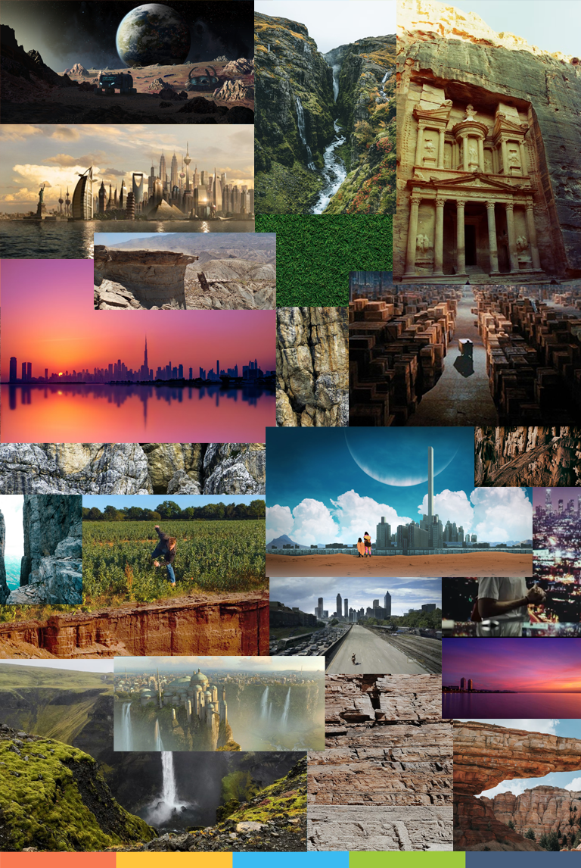

Figure – Mood board with textures and shot ideas from other films

### Storyboard

#### Foreground

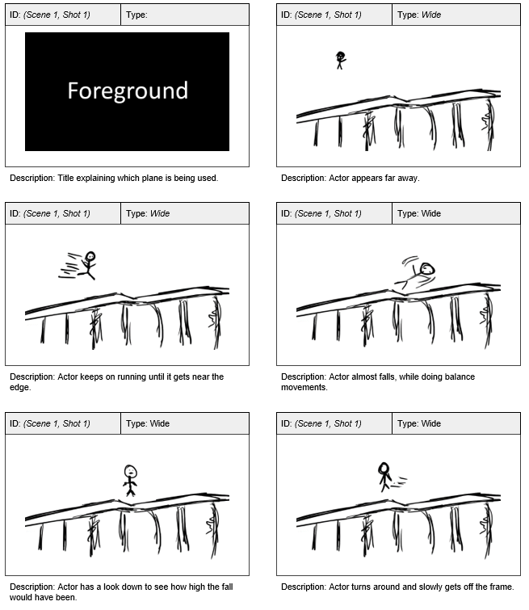

Figure – Storyboard idea for Foreground shots

#### Background

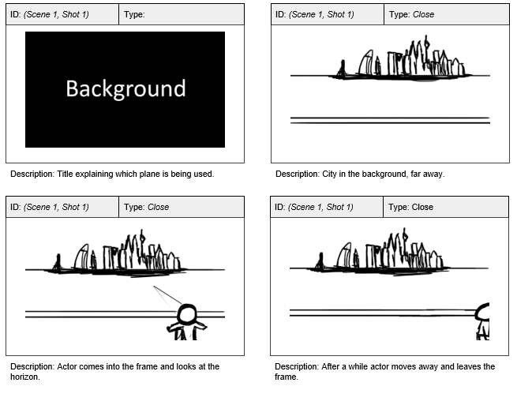

Figure – Storyboard idea for Background shots

## Planning

### Cast

To keep simplicity of the project and add flare to the shots, one actor would be necessary as without him/her the shots would look boring. A friend or a good actor would be the best options to star in the shots that had been planned. However, after some communication, there was no one available at the time, that wanted to take part in the recordings, as everyone was busy with university or work. This would only become a problem during Production, as recording and acting might have become a bit too much to cope with and achieve the results expected. Not everything was bad, as this put me in a position of not needing to create forms of responsibility for the actors and crew alike as it would only be my responsibility if anything wrong happened.

### Risk Assessment

In every video project it is necessary to understand the risk involved to anyone that is part of the crew. In this case, there were only two shots that needed to be recorded, and the only problem that came to light, was the running by the actor which could make him fall, but this could not be avoided at all, luckily it was a trivial occurrence which would not put anyone in any major danger.

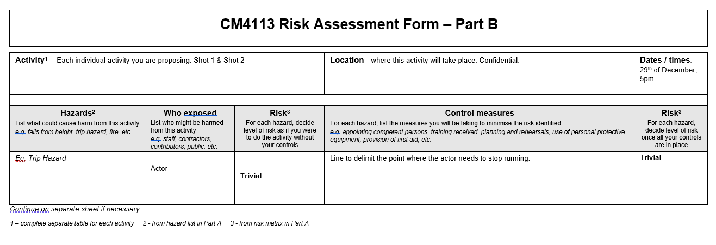

Figure – Risk Assessment Form

### Film Call Sheet

A film call sheet is a necessary piece of documentation to be sure everyone knows where they must be, what kind of clothes they should be wearing and at what time. Crew and actors normally do not go to the set at the same time, as there is a need to set up cameras and other hardware, which takes time, and actors can get fed up easily with unproductive hours.

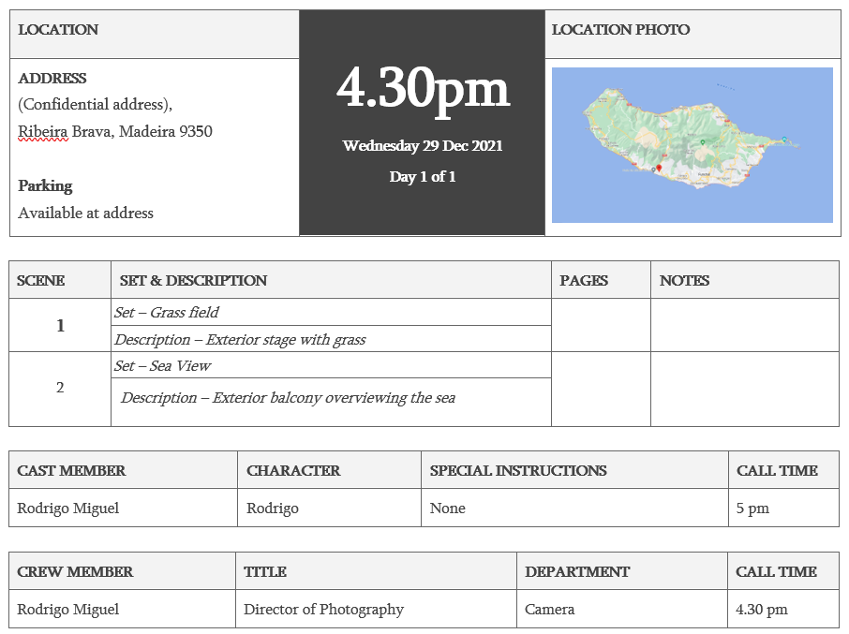

Figure – Call Sheet - Complete with information

### Shooting Schedule

Another document that must be planned before any shoot, is the Shooting Schedule. This is mainly used to organise and put everyone in the same page before and during a shoot to make it as seamless as possible. This way the crew can set up the shoots beforehand and the actors will only arrive when really needed. This makes everything more efficient and self-sustained with more organisation and less dead times.

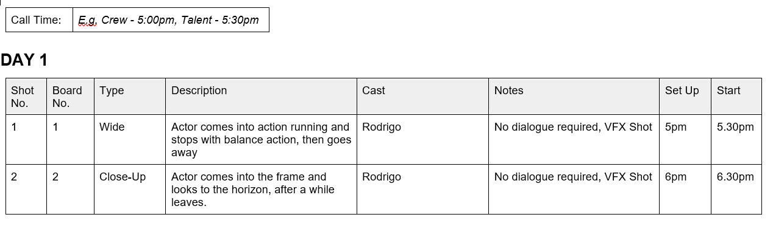

Figure – Shooting Schedule with information

## Equipment Analysis

#### Camera

To record the shots necessary to later be edited the use of any smartphone nowadays would have been enough, however, using a DSLR or Mirrorless camera will give better results overall. Owning two cameras, it was a matter of choosing which was better for the job that was planning to be carried out.

The cameras that were available were the Nikon D3300 and the Canon M50 (figure 13). Both cameras have a CMOS format sensor (APS-C or Cropped), with comparable performance. However, there are differences regarding the shooting resolutions and Auto focus abilities. The Canon M50 comes out on top on the resolution, as it is possible to record in 4K against the Nikon’s full HD. Adding to this, the Canon has ultra-fast head focus tracking, which helps at automatically focusing on the subject without any input from the videographer. The Nikon on the other hand does not have any of these features losing points in this comparison. Also, as a comfort creature, the Canon weights less and the smaller form factor are big advantages when shooting video. Being a mirrorless camera makes no difference in a video setting. Lastly, without having to buy any more accessories, the advantage of owning two lenses for the Canon helped solidify the camera choice.

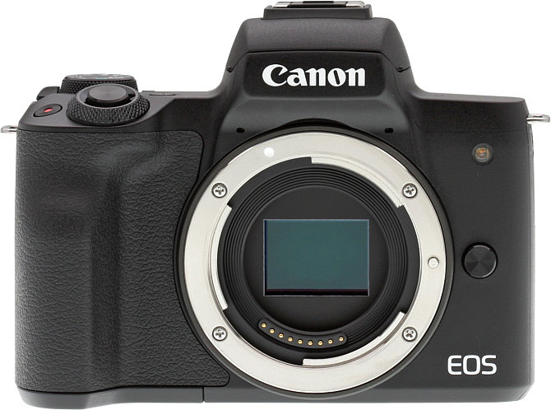

Figure – Canon M50 body (Anon., n.d.)

#### Lenses

When choosing lens for a film, the more the merrier, however, these come at a cost, and need to be chosen in a cost-effective way for smaller studios or one-man team. In this case, while both kit lens available in both cameras, when compared, are of similar quality, the availability of a zoom lens (Canon EF-M 55-200mm f/4.5-6.3 IS STM) on the Canon M50 gives it more usability if there is a need to produce any of the shots that the standard Canon EF-M 18-55mm f/3.5-5.6 IS STM (figure 14) kit lens is not able to produce.

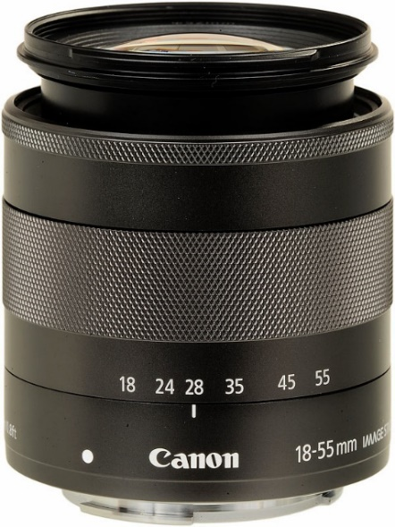

Figure – Canon EF-M 18-55mm f/3.5-5.6 IS STM (Anon., n.d.)

### Other Equipment

In conjunction with the lens, a K&F Concept 52MM Polarising Filter was available to use if the shutter speed and aperture of the lens was not enough to eliminate the reflections present in the shots. Also, to aid the solo recording of the clips, a cheap tripod was used. The Amazon Basics 60-inch Lightweight Camera, DSLR and Binocular Tripod did its job of being fixed in place and gave me the ability to angle the camera to different positions and allowed me to act in the shots without any major inconvenience.

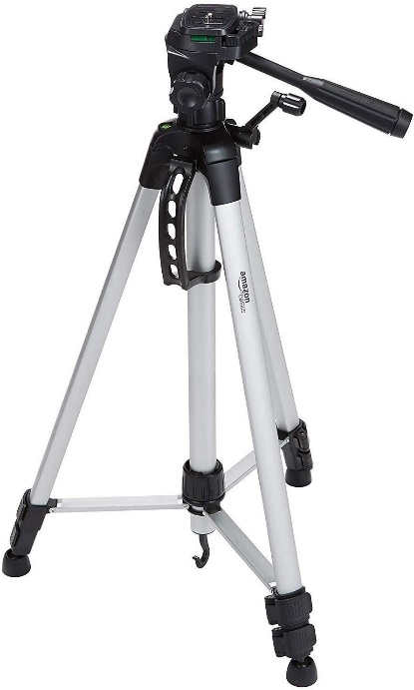

Figure – Amazon Basics 60inch Tripod

## Software Analysis

#### Photoshop

Photoshop is widely known for being the top-grade program to edit photos, being it for simple touch ups or complete overhauls of images to improve how they look. By deciding that Photoshop would be the best software to build the digital 2D environments as I already had some experience from previous years, and felt it was very user-friendly with its user interface while professional results could be achieved if used correctly.

#### Blender

Blender is a 3D creation tool which I was introduced in my third year of university. With some know how it is probably the best application to try and build 3D assets that can later be merged in the shots that I planned to record. Even though the lack of skill is present, its use is not rocket science, therefore putting me in a position of doing a good job, or at least, bring average results. Other 3D tools could be used, but in a project like this, time is of the essence and time lost in relearning how to do certain tasks can be invaluable later in the pipeline.

#### Adobe After Effects

After Effects is known as the beginners’ visual effects tool therefore being the go-to program to start off with. By being a powerful beginner friendly tool, aided with an enormous catalogue of tutorials online compared to other video manipulation tools (e.g. Nuke, Houdini), it was probably the best option to mask out and blend in details that would need to be composited together while using the assets created previously.

#### Adobe Premiere Pro

Premiere Pro is a well-established video editor application on the online video world. With its powerful tools and features it was the obvious choice to work alongside After Effects as they have similar user experiences and features that are transversal between both software’s. With some knowledge in Premiere Pro, its features would not impose a challenge to get an edited video presentation to show the resulting product.

## Requirements Analysis

### Introduction

The requirements analysis necessary for this type of project is like the development of any movie. There will be three stages, pre-production, production, and post-production, of constant recording, editing, and learning, with a later stage added, that will focus on user testing and conclusion gathering. The project will focus on trying different set-extensions techniques (Matte painting in 2D, 2.5D and 3D) and compare them to try and conclude on when they should be used, to have the best outcomes while diminishing money and time spent to achieve, a similar, result. The requirements will follow the agile method, MoSCoW, which helps with the prioritisation of the tasks for each step of the development journey, with Must, Should, Could and Won’t have requirements.

### Pre-Production

#### Functional Requirements

* MUST research on which are the best angles to shoot from, to not have to use keying devices in Production.
* MUST have previously, taken research, on shots that are possible to achieve and do not put any member of the crew in any type of danger.
* MUST have some sort of script, even if it does not have dialogue, to make things clear during production.
* MUST have one or two storyboards of how those shots should look like during production.
* MUST follow the thoroughly the plan, with viable scheduling to accommodate every planned scene.
* MUST have a plan regarding budgets and equipment that needs to be used during production.
* SHOULD have studied pieces of film that use Matte Painting to extend their sets, in the analogue era. (e.g. Metropolis (1928), Citizen Kane (1944), Blade Runner (1982), etc.)
* COULD have analysis on films, that were well acclaimed, and that used analogue digital painting techniques.
* COULD have planning on recreating 2-3 scenes from these films with newer digital painting technologies available at the time of the honours project.

#### Non-functional Requirements

* MUST ensure that any participating entity is fully aware of their rights to withdraw at any time.
* MUST include a choice of locations that make it possible to film on-site.
* MUST have a plan B if the shooting cannot be done at the location chosen in the schedule day.
* COULD include a shot list.
* COULD have a rehearsal on the days prior to the shoot.
* SHOULD the author of this project try and get used to the camera equipment that will be used on the shooting.
* SHOULD have permission to shoot in certain locations, if necessary.
* WON’T plan for any trailers.

### Production

#### Functional Requirements

* MUST record live action plates which have very defining foreground, mid-ground, and background.
* MUST follow the planned schedule discussed in 2.1.
* MUST record sound with the use of an external camera microphone (Rode Go or similar).
* SHOULD make the clean plates as stable as possible as a way of minimising the need for rotoscoping in post.
* SHOULD be recorded outside, if possible, to have natural light light-up the scene.
* SHOULD include different backgrounds in the shots.
* COULD have interior shots if there is enough light or if lighting equipment is available at the time of the shooting.
* WON’T use mobile captured footage.

#### Non-functional Requirements

* MUST not exceed the budget plan established in Pre-Production. If this, indeed happens, there is a safety net of £200 to use on any unplanned expense.
* MUST use equipment that is available at the time of production by the author of this honours project and/or use equipment that is available by the university, Robert Gordon University, or by acquaintances, to keep the production budget to a minimum.
* MUST give sustenance to any crew members that might be helping during the shooting days.
* SHOULD keep aid to a minimum, only having one producer (the author of this Honours Project) which will be doing everything on their own.
* SHOULD consider the necessity of other actors if the planned shots do need.
* SHOULD try to keep to a minimum, the appearances of peers that are not part of production in, on-site recordings.
* SHOULD not have more than 3 persons on-set at all times.
* COULD include use of drones to get any necessary shot.
* COULD include stock footage if it is promptly available and free to use in non-commercial work.
* WON’T use equipment that is not available to a low-budget production.

### Post-production

#### Functional Requirements

* MUST follow the matte painting techniques that the honours project is trying to take conclusions on.
* MUST be able to be fully edited in a “normal” computer.
* SHOULD add sound effects where necessary.
* SHOULD use, freely available, internet materials to use in any of the 3D modelling objects.
* SHOULD use smart problem solving to fix any problems that might arise during post-production that were not found during production.
* SHOULD use tutorials to get proficient at a certain technique if need be.

#### Non-functional Requirements

* MUST consider rendering times, which can become slower as effects are added.
* MUST use Adobe Photoshop to create 2D matte paintings.
* MUST use Blender to create 2.5D and 3D set extensions.
* SHOULD use video editing software that is either free, or given for free, by the University. This includes Da Vinci Resolve, Premiere Pro.
* SHOULD use Visual Effects software that is easy to obtain and easy to work on as a beginner, e.g., Adobe After Effects.
* COULD use Nuke or any other professionally used visual effects program if any of the necessary techniques cannot be achieved in the software considered in the MUST section.
* WON’T outsource work to be done by other artists.

### Final Product

#### Functional Requirements

* MUST have at least two different shots, each edited with three of the different matte painting techniques.
* MUST have at minimum 6 different exported files. Three per clean plate recorded.
* SHOULD have the final shots exported in Full HD (1080p).
* SHOULD have a minimum duration of 30 seconds per shot.
* COULD have the combined final shots create a short film, in a logical way.
* COULD have a final shot will all three techniques combined to see if they can co-exist seamlessly.

#### Non-functional Requirements

* MUST have an exported file per shot with the different techniques used.
* MUST use easily reproducible video file format, e.g .mp4, .mov, .mkv.
* MUST consider quality vs. compression when choosing best file format.
* MUST be uploaded to a free video uploading website (e.g YouTube, Vimeo).
* SHOULD have a max resolution of 4K (3840 x 2160 pixels), although 1080p (1920 x 1080 pixels) is recommended.
* SHOULD be completed and have every step jotted down in a project log file.
* COULD have subtitles to help hearing impaired people to follow suit any dialogue or sound effects that might be present.
* COULD have an explanation of what the point of the research is, so that people that are watching it know what to look for.
* WON’T have any exported file under 720p (1280 x 720 pixels) of resolution, as this will hinder the quality of the visuals present in the shot.

### User Testing & Opinions

#### Functional Requirements

* MUST be done via survey to be able to have a broader opinion gathering from different people around different working sectors.
* MUST have more than 10 participants to get a more trustworthy conclusion regarding choices.
* MUST give the participants a way of watching the scenes with the different set-extension techniques applied.
* SHOULD have questions that touch on how the shots look qualitatively regarding the visuals.
* SHOULD have questions regarding how much, participants think the full production cost.
* SHOULD question the participants what their understanding of VFX is and if they are professionals in the field.
* COULD contain questions regarding the time that it took to get the final shots done.
* WON’T ask the participants for their information.

#### Non-functional Requirements

* MUST carefully thread questions that are easy to understand for film enthusiasts and visual effects professionals.
* MUST explain to the participants what the survey is about and that they can withdraw at any time before and during it the query.
* MUST be an anonymous survey, so that users can answer it with way more honesty.
* SHOULD have every question marked as compulsory, to leave no ambiguity on the query.
* COULD contain a maximum of 15 questions.
* WON’T have less than 5 questions.

### Conclusion

In conclusion this section touches on every requirement that needs to be considered before starting the building stages of the honours project. It gives a thorough understanding on which steps need to take priority during the different production stages and helps on the creation of a project plan that will have to be done during pre-production. It also shows that there is a need for research to be done, being it from watching what other filmmakers have done in the past, to what it possible to do now with digital set-extension techniques. Overall, there is still room for improvement on some project choices and that nothing is set in stone, however it is recommended that every step is followed as planned which should not only bring an easier pipeline to whoever is commanding the project, to everyone that participates in it.

# Implementation – Production and Post-Production

## Introduction

This section will touch on the issues of implementation, what processes were used and how any problems were overcome. How the hardware and software mentioned in the planning phase was used and what was done from the recording of the clean plates to the final presentation done to be presented alongside the poster. Everything will be explained to a certain level of detail to allow for a recreation of the exact same output if someone may wish.

## Production

To start off with production, it was necessary to record the plates (say video) where the compositing will be done on top off. This required equipment and can be done solo or in group. For this project, it was decided previously, that the implementation had to be done alone using the equipment discussed in the Planning section.

### Setting up the shots

Setting up the shots was a matter of trial and error with lots of “check frame, hit record, act on front of it, stop, check camera, reframe, repeat”. Both shots were recorded at around 5 pm during wintertime in Madeira, Portugal. The sun was low and around 30-60 minutes from setting down.

#### Foreground

The foreground shot (Figure 16) took a couple of tries to be correctly setup, framing and exposure wise, as an in-camera Flat custom colour profile was being used. The plan was to have a wide shot where there would be a nice amount of cliff that could later be added from one side to the other of the frame, however, in such a tight location, this did not come out as expected. The camera was also with a weird angle that did not help in the post-production work. The acting was the most difficult part, and the recording would have benefited from someone that could fake an ‘almost fall’ better. After 20 minutes, the takes were sufficient for what was planned and the decision to move to the next shot was made.

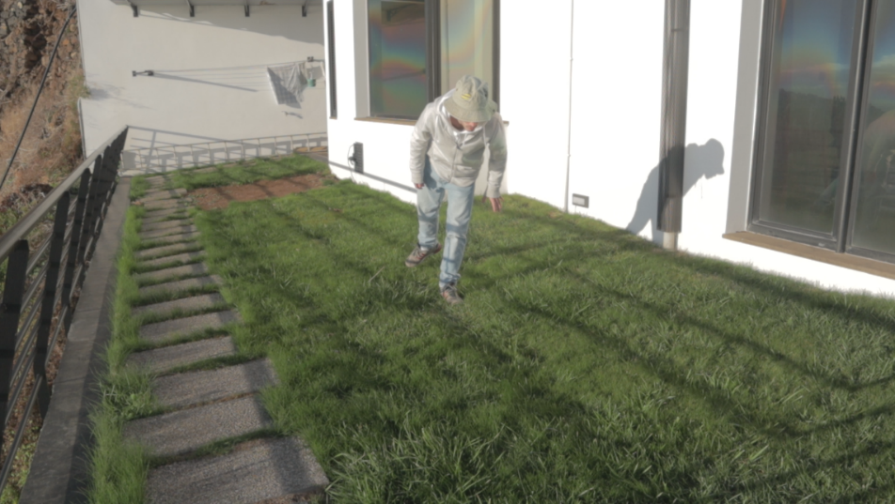

Figure – Frame of clean plate – Foreground

#### Background

The background shot (Figure 17) was recorded right after finishing the foreground shots. In a slightly different location, focusing on the sea front. The director wanted to have a close-up shot from the camera perspective and have the actor show up on the scene and look around while maintaining the background simple for editing purposes. The camera lenses zoom capabilities were of good use, as they hid the balcony and created a framing composition that the director envisioned. Unfortunately, no notes of the lens settings were taken while recording, something which will be discussed later, in the reflection section.

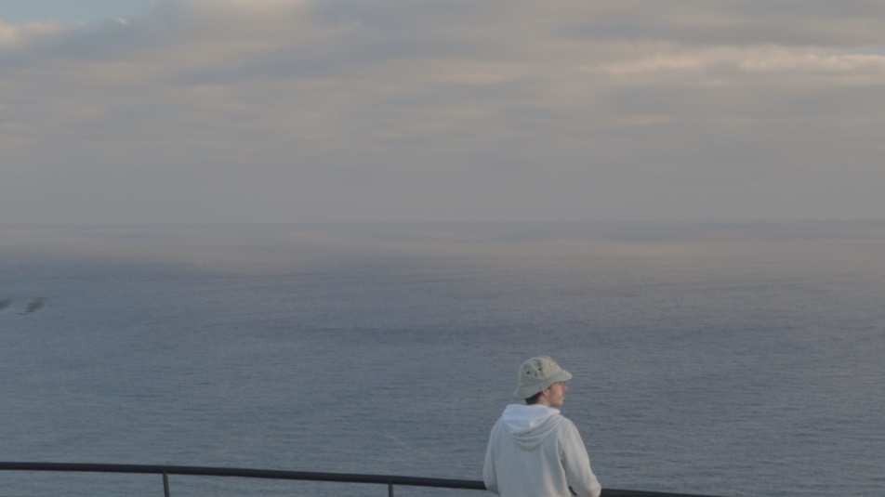

Figure – Frame of clean plate – Background

## Post-Production

### Importing and Preparing the Raw Footage

Next thing to do, was to import the RAW files, which were over 1GB in size all together and import them to Premiere Pro (Figure 18), to choose which ones were the best, cut and assemble them accordingly. Also, during this edit, the video editor chose the best usable frame in both plates and exported to be used later in Photoshop and Blender as a reference image.

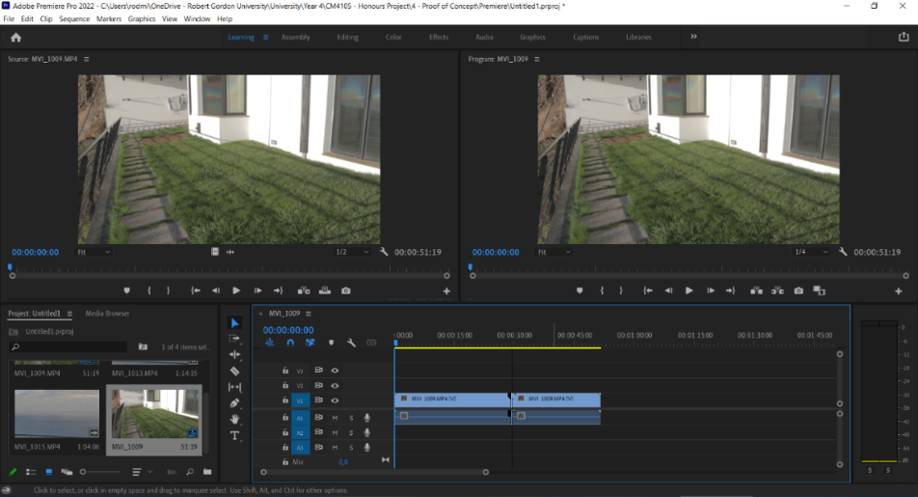

Figure – Premiere Pro Assembly Workspace with Raw Video Files

At this point, there was some playing around with the colour correction of the clips, which was a mistake, as it became a problem later down in the implementation process, when blending the assets together, proving to be unnecessary work, that should have not been done so soon in the pipeline.

### Foreground Shot – 2D Created Assets – Attempt #1

The first step to start editing the image was to hide the mirror on the wall as it broke the realism and the immersion to the person watching. The building of the fake wall started by creating a new layer and using the eyedropper tool to match the colour on the wall edge near the window and paint over it with the brush tool. At the same time, it was decided to start playing around with the fake cliff and see how far things could go. For this, a stock image found on google was used and after playing around with its position and perspective this was what it looked like (Figure 19).

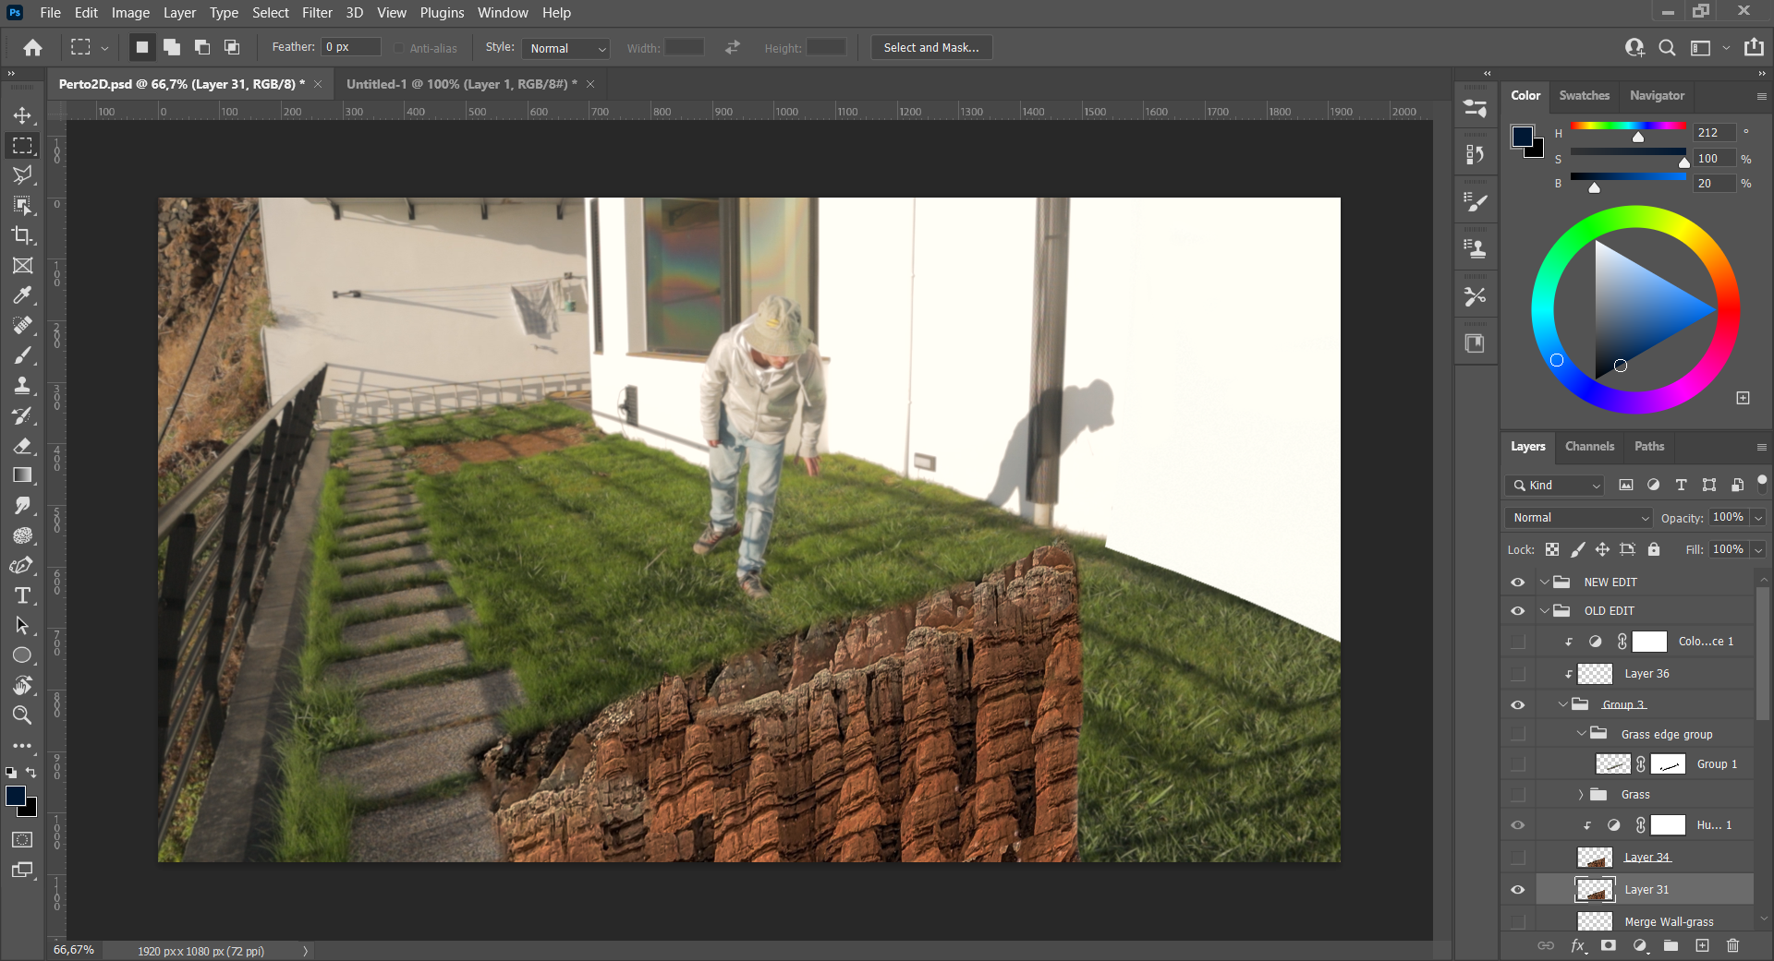

Figure – Foreground attempt #1 – added wall and cliff rocks

Next, with the help of the lasso tool, patches of grass were copied and masked across the rock path present on the left side of the frame. Also, there was a need to blend the grass where it meets with the rock cliff, for this, another google image was used to blend the edge the best way possible. This did not look great but continued before asking for feedback. A continuation of the wall was added to then see how the intersection between the rocks and the wall could be implemented (Figure 20).

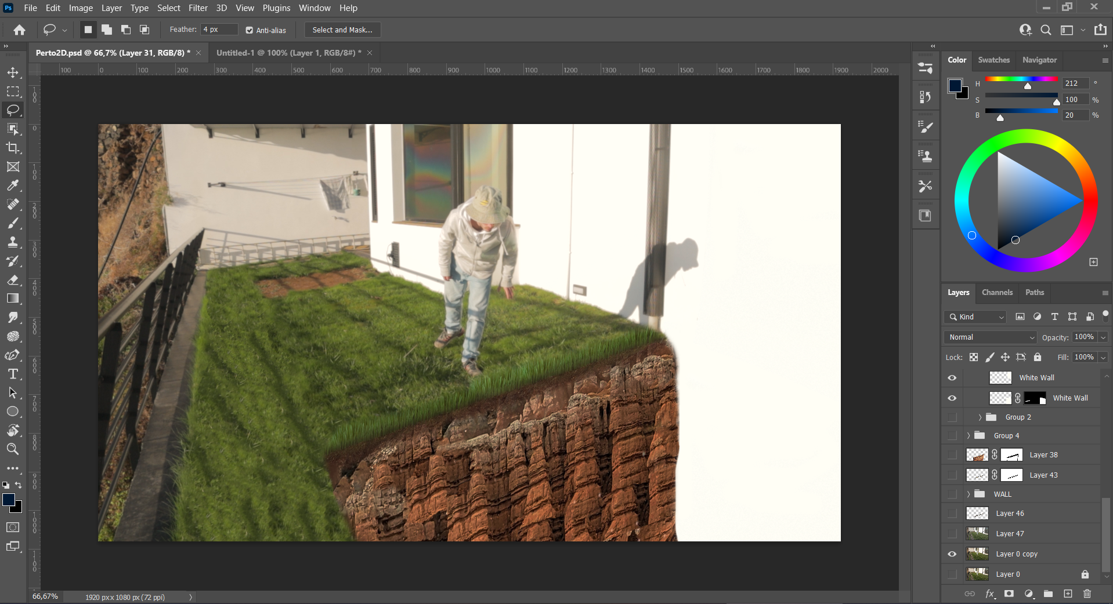

Figure – Foreground Attempt #1 – Continuation of the wall

With the addition of some blending brushed colours and minor details, a shadow on the wall and a minor, darker, shadow in the place where the cliff intersects the wall, was added. Also, a Hue/Saturation mask was used on the cliff layer to make it slightly darker and blend in better. This is what attempt #1 looked like (Figure 21).

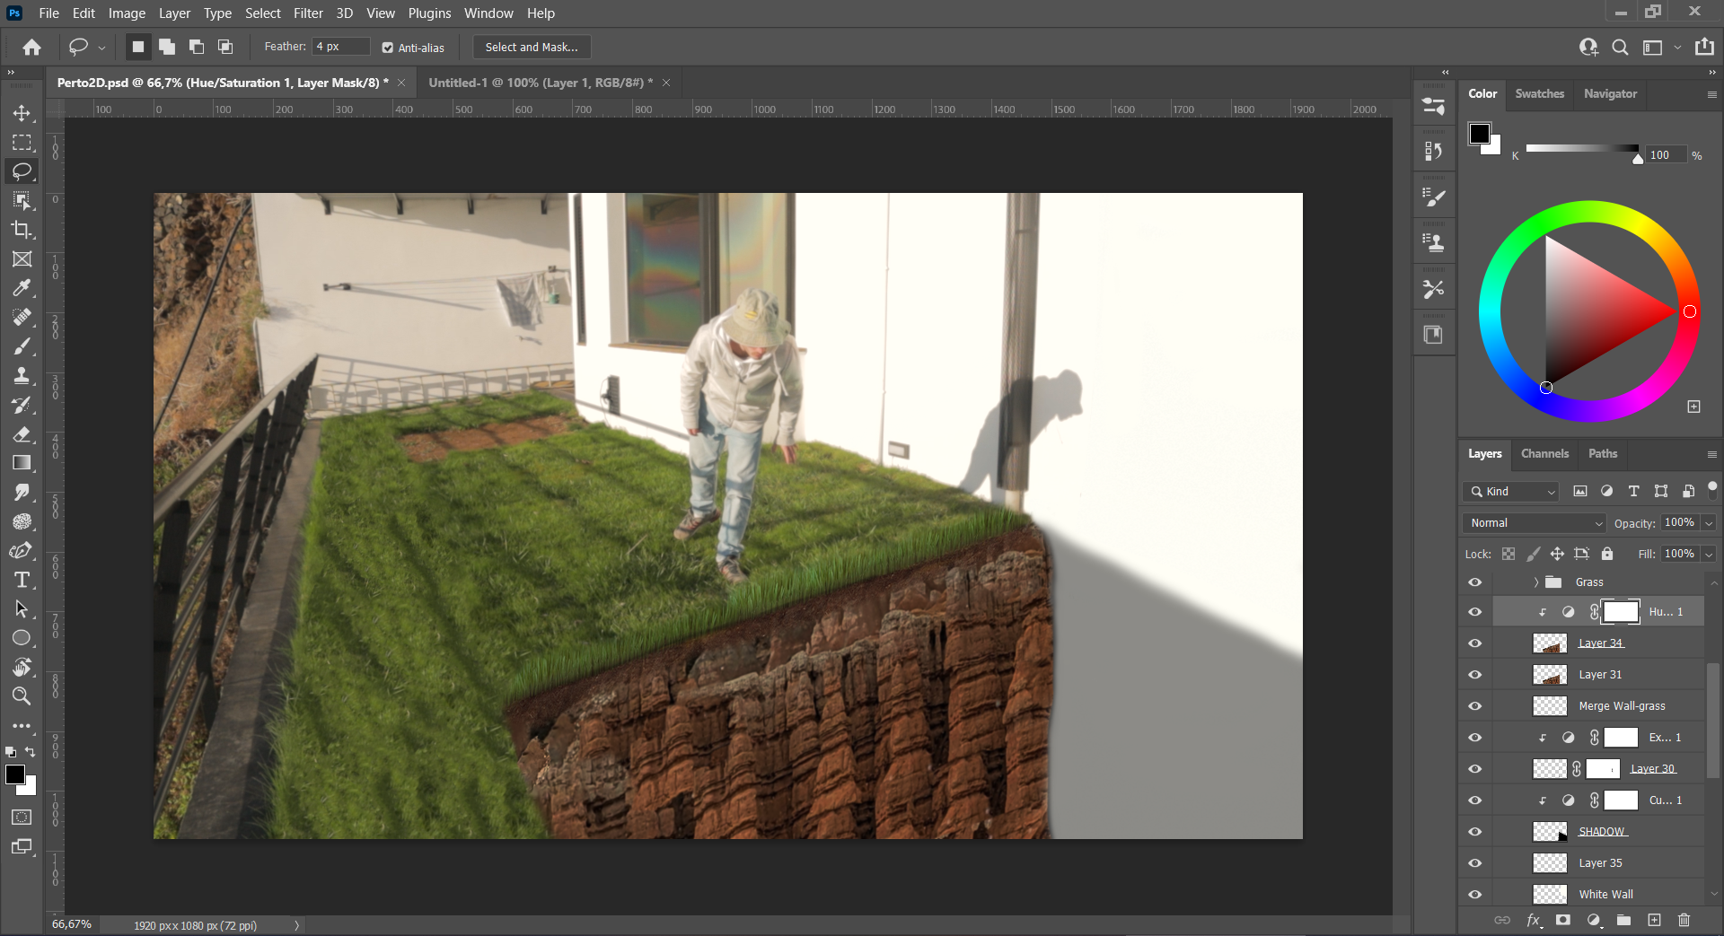

Figure – Foreground Attempt #1 – Final Matte

### Foreground Shot – 2D Created Assets – Attempt #2

After the proof-of-concept meeting, every piece of advice/feedback was taken to its full potential and starting over in a new Photoshop file with the experience and ideas from the previous one was the best option. Again, the process started by importing the clean plate, this time without the colour correction, to match the colours more easily later. After some research a mountainous photo was found online and used as a reference for the cliff (Figure 22).

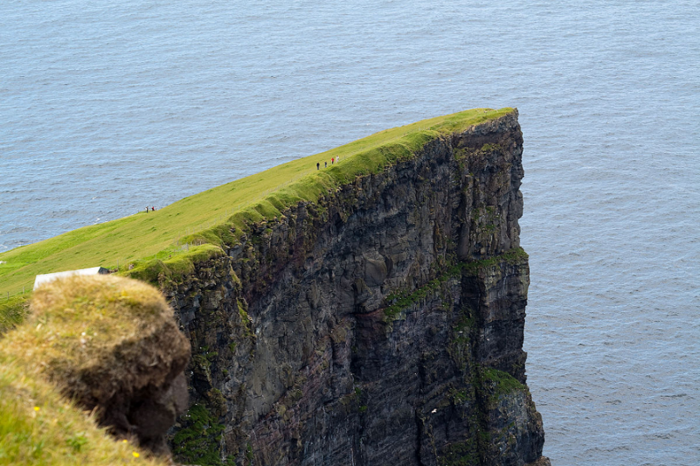

Figure – Cliff image (Refence lost)

With the use of masking tools (lasso tool), feathering options and some positioning, the fake cliff was created and the hiding of the rectangular rocks on the left of the frame could commence. Its object was to blend them better with the top of the cliff by using the lasso tool and pasting patches of grass on top of them. The wall was still missing, by painting over the windows with the brush using the same colour as the wall (collected with the eyedropper) and then patching it up with the masking tools available in Photoshop (Figure 23).

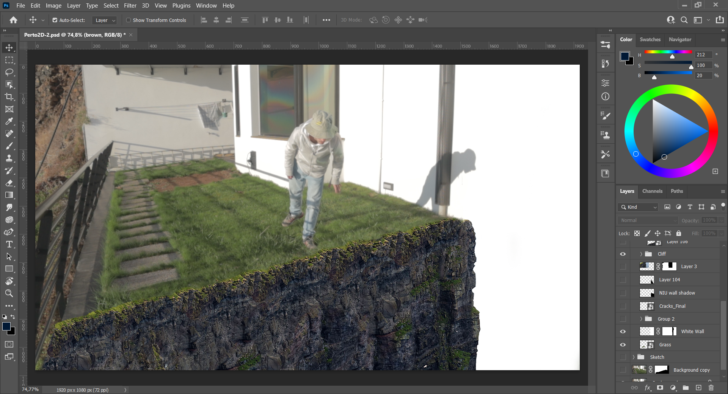

Figure – Foreground Attempt #2 – Cliff, grass, and wall

At this point, the cliff was still missing some realism, so other transformations were applied to it. By duplicating it, the “original” was still preserved in case something went wrong. To achieve this a blur filter, darker colour brushings, to make it darker at the bottom, and a darker line on the right side of it where it intersected the wall was added to hide some imperfections. The use of an adjustment layer to fix the “curves” of the cliff and grass was used too. On the top, where the grass meets the cliff, adjustments to the blur and colours were done to make them blend in better. Considering the feedback from the proof-of-concept meeting, a shadow in the wall with a slightly more downward angle and cracks on the wall were added, to make it more realistic as if the world was falling apart. To finish off, a brown effect was added to the cliff to add a bit of colour while haze was also added to get away with imperfections in the matte. This was what the final matte looked like (Figure 24).

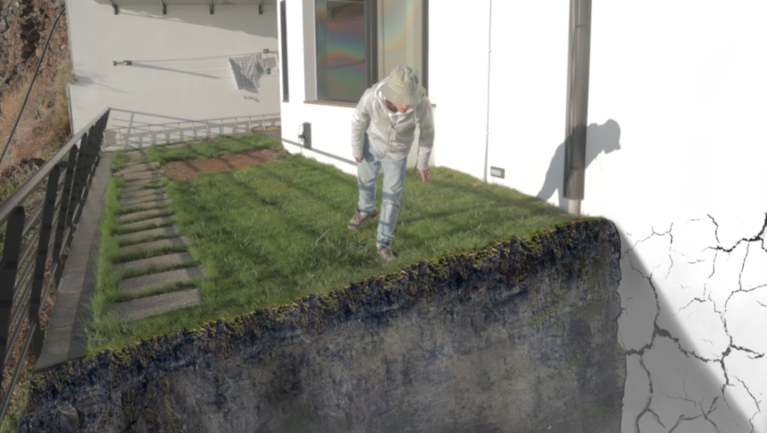

Figure – Foreground Attempt #2 – Final Matte

### Foreground Shot – 3D Created Assets – Attempt #1

#### Setting up the scene

Having done the first attempt in the 2D image assets, it was decided to try in the 3D one before asking for feedback from the project supervisor. Booting up Blender, the first thing to do was to delete the default cube and add the exported frame to the camera. Then, the camera had to be moved to match the perspective lines the most possible to maintain the perspective that was captured with the video-camera. Here, the focal length of the Blender camera should match the one used during the recording, thing which did not happen, because no notes of them were taken at the time. This will be discussed later for the future work with ideas on how to circumvent this. To match the camera and position, on the right-hand side, with the camera selected, the option to add a frame or video to the camera view was possible (Figure 25). Here it is also recommended to adjust the opacity of the background to 50%.

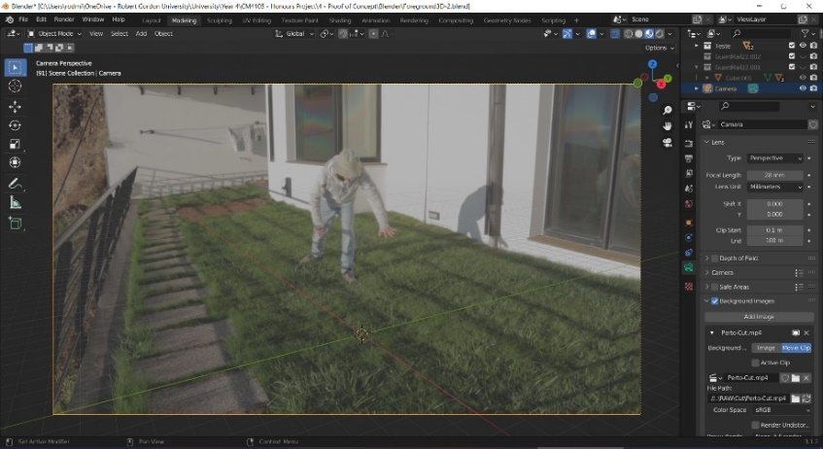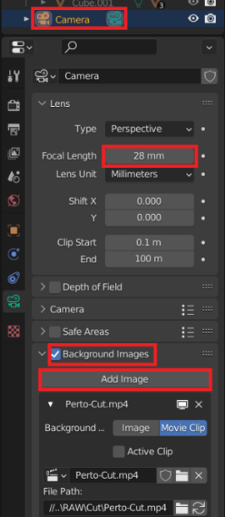

Figure – 3D Foreground Attempt #1 – Added reference shot and camera adjust

Afterwards, the first thing to do was to start by building the wall to hide the window on the right side of the frame. In the ‘Modelling’ tab, a plane was added and in ‘Edit Mode’ its size was changed to one that would be fitting for the shot. Consequently, another plane was added to be the cliff/mountain/rocks. This plane was rotated 90 degrees to be vertical like the wall but perpendicular to it. A ‘Multiresolution’ modifier was added, to allow for more depth and build of rocks on the plane. Now that the cliff was (Figure 26) it was time to work on the grass to then start shading the whole scene. To model the grass, a new file was opened as to keep the workspace organised.

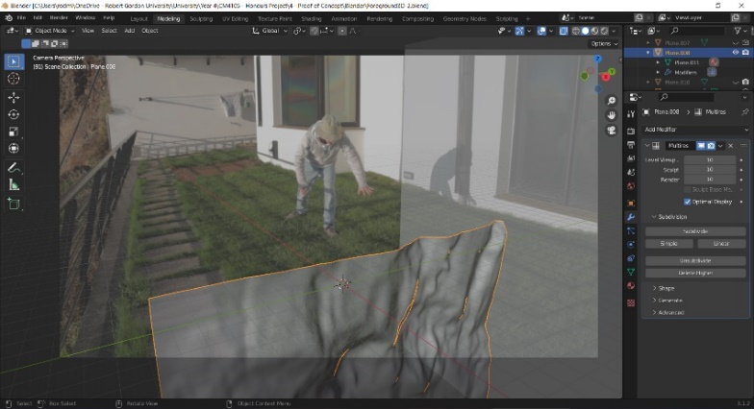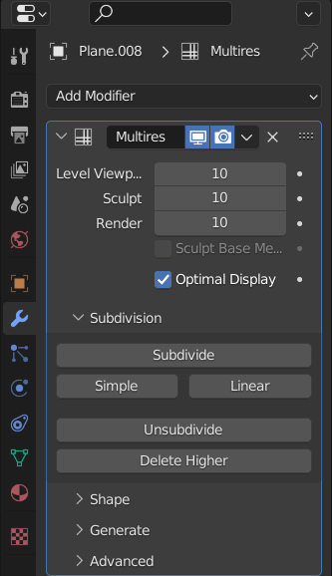

Figure – 3D Foreground Attempt #1 – Multiresolution modifier

#### Generating the grass

Basically, what was done here, was that a terrain was generated, then a basic plumule of grass was modelled, the particle system was used to distribute it through the built geometry and then some shading was applied to make it more realistic.

On a new Blender file, the default cube was deleted and a new plane with subdivisions of 10 by 10 was added. The shade smooth option was applied. Next, a ‘Displacement’ modifier with 0.5 strength was added alongside a new texture with the ‘clouds’ option selected, with its scale changed to 2 (Figure 27).

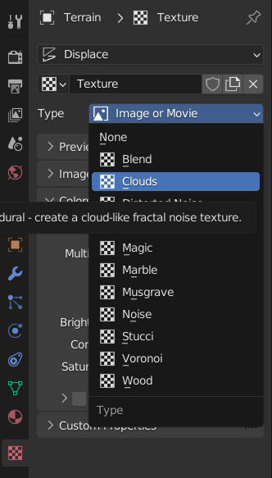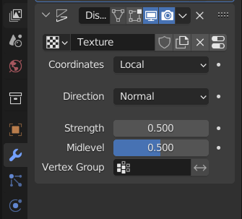

Figure – Generating grass – Displacement & New Texture

After being happy with the results, back in the ‘Displacement’ modifier ‘Apply’ was hit. Moving the terrain aside, the modelling of the grass started. By adding another plane and reshaping it to a single blade, an array modifier of value 10 was added and changing it’s offset of X to 1.1. Then the ‘Array’ modifier was copied and the offset changed, again, but this time on the Z axis. Lastly, the mesh was rotated to be pointing upwards in a vertical position. While the mesh was still selected, the ‘Separate’ function was used to separate by ‘Loose parts’. Completing these steps allowed the activation of the ‘Randomise Transform’ command which enables the change of location, rotation and scale of the grass, to make it look more random (Figure 28).

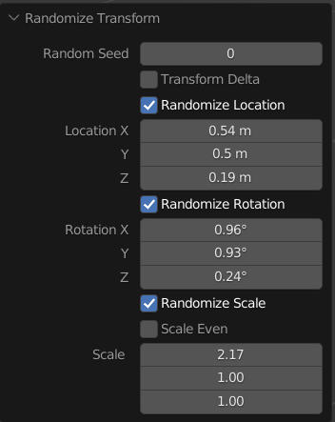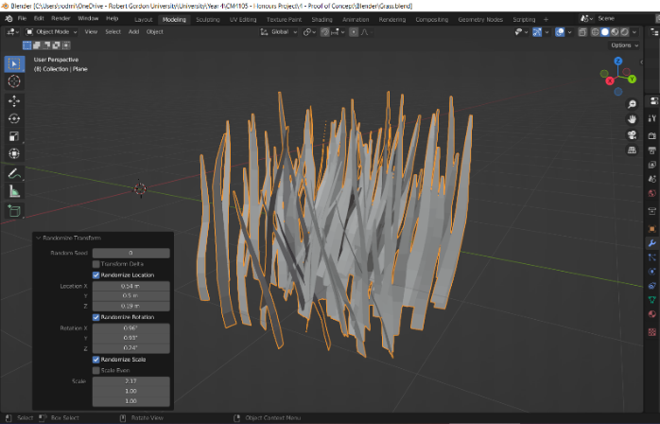

Figure – Generating Grass – Randomize Transform Values

To randomise it, even more, the object menu was used and the ‘Join’ command allowed the use of the proportional editing tool available in Blender to achieve a better result.

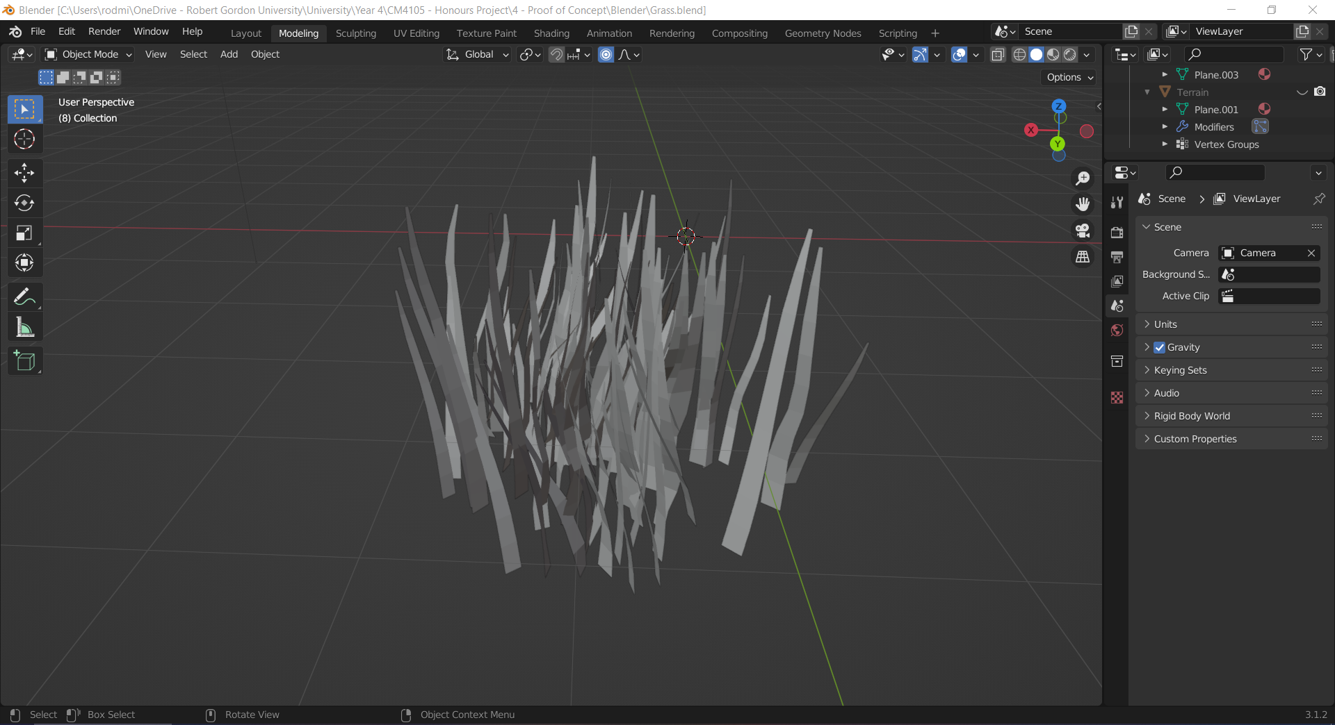

Figure – Generating grass – Final Model of patch of grass

With the grass now created (Figure 29), it could start to be distributed in the terrain created earlier. This was done by selecting the terrain and creating a new ‘Particle Settings’, with the ‘Hair’ option enabled with 10000 numbered particles. The ‘Render’ settings were put into ‘Object’ and the patch of grass selected. To add variation, the ‘Scale Randomness’ was set to 0.411. Also, by enabling the ‘Advanced’ option, more random rotation was added to the particle system. After this, the recreation of the texture steps done previously with the cloud settings was done, but this time, under ‘Texture’, the ‘Influence’ section was enabled, and the ‘Density’ and ‘Hair Length’ used to control the distribution and density of the grass on the terrain. Also, the ‘Colors’ section was used to adjust and play around with the distribution of the grass patch. The sliders of ‘Brightness’ and ‘Contrast’ could also be used to perfect the output that was desired for each terrain. Before starting the ‘Shading’ process the terrain with the grass looked like this (Figure 30).

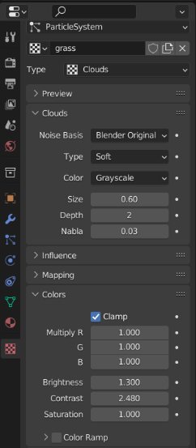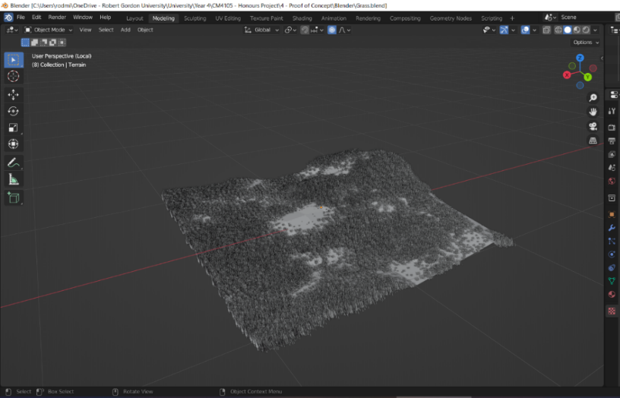

Figure – Generating Grass – Terrain with grass and grass texture settings

#### Setting up the scene to start the shading process

To start off the shading process, the grass Blender project needs to be appended to the first project file, as it made more sense to start the shading process there to match the colour of the grass with the original matte. An HDRI that matched similar weather and lighting conditions on the day of filming was found and added. This can be a make-or-break moment for any project, as it is not an easy task to find and HDRI that is suitable for every weather, hour of the day or environment. The one used here was ‘Sunset in the Chalk Quarry’ (Figure 32) due to having a similar sun set angle and look compared to the day of recording.

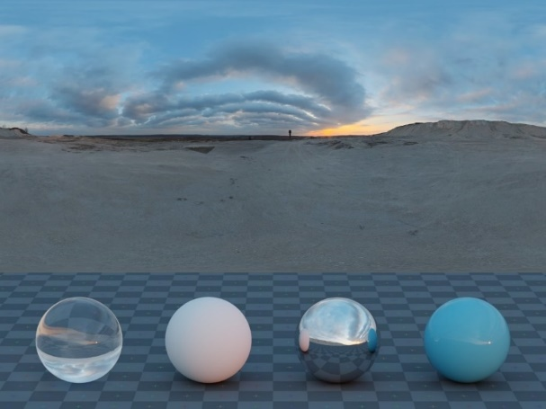

Figure – Sunset in the Chalk Quarry (Majboroda, n.d.)

After importing it to the World and adding the Mapping and Texture Coordinate with Node Wrangler, the node settings were the default ones only changing the rotation of the HDRI on the Z axis to 45º to match the shadows between the recording and the HDRI.

#### Shading the grass

Now that the scene was well lit, with similar lighting to the day of the recording, the terrain was modified to fit better in the environment it was meant to be blended into. By going into the ‘Shading’ section, colour was added to the grass by creating a ‘ColorRamp’ node with two different shades of green. For the coordinates, they were automatically created using the ‘Mapping’ and ‘Texture Coordinate’ nodes by Node Wrangler addon. Also, it was important to enable ‘From Instancer’ on the ‘Texture Coordinate’ node to allow for a nice colour variation. The end results in Cycles rendering mode looked like this (Figure 32).

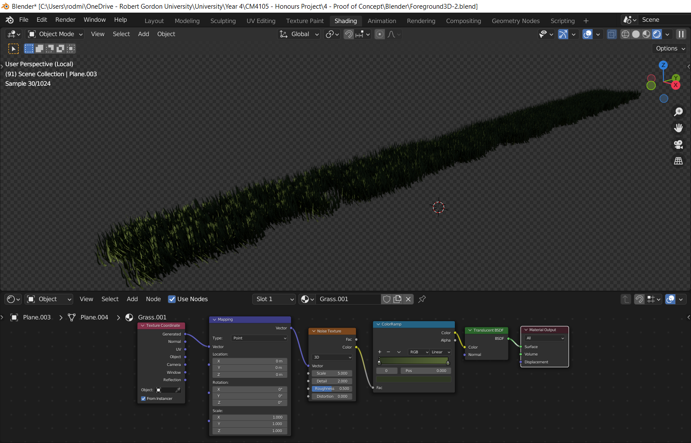

Figure – Grass shading node settings and Cycles Render on top

#### Shading the cliff plane

At this point, it was decided to go for a texture-based shader to make the process easier, as there was a lack of knowledge about node shading and how to create node generated textures. After some searching, the finding of the texture ‘Rock 038’ (Figure 34) was done and added to a new material with the help of Node Wrangler functionality ‘Texture Setup’, which automatically selects the texture maps to the correct nodes.



Figure – Rock 038 texture (Anon., n.d.)

After some adjustments to the ‘Principled BSDF’ were done, these were the settings that were selected and how the cliff looked in Cycles (Figure 35).

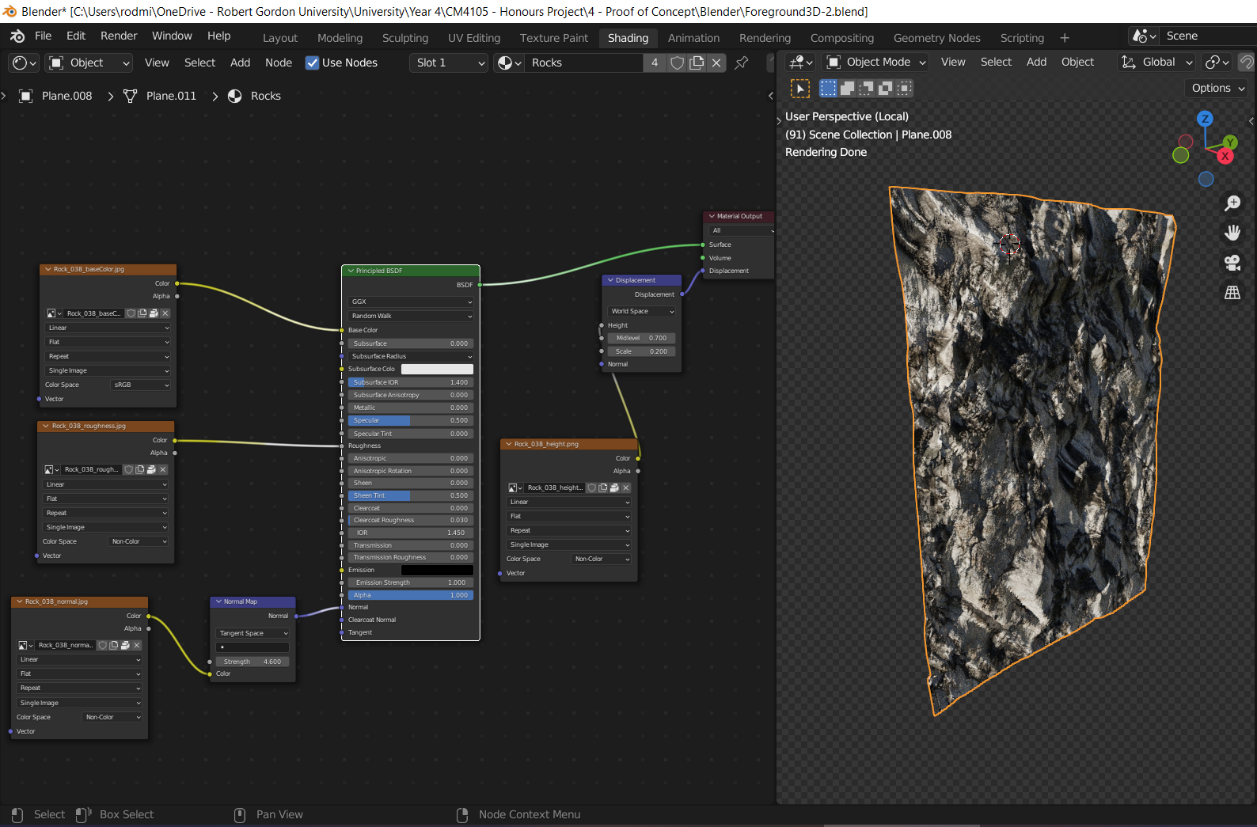

Figure – Shading cliff/rocks node settings and render in Cycles

#### Shading the wall

The only object that had no shader yet was the wall that hid the window with the reflections. Its material was achieved, only, by playing around with the ‘Principled BSDF’ making it match the original frame colour and blending it the best possible.

#### Finalizing the Scene and Rendering

Back in the ‘Modelling’ tab, the objects were moved to match their positions on the frame and were prepared to be rendered. The grass terrain had to be duplicated to cover the rectangular rocks on the left side of the frame. When the final positioning of the objects was set, the assets were rendered (Figure 35).

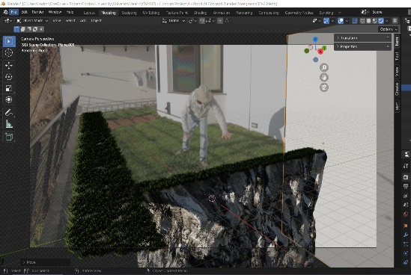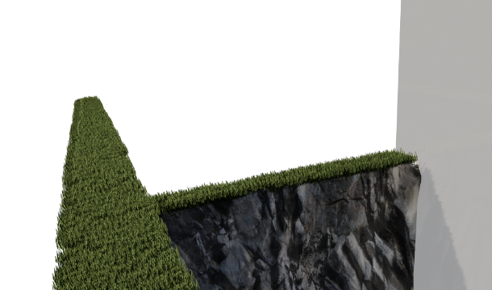

Figure – Final Positioning of the objects and Rendered Assets

### Foreground Shot – 3D Created Assets – Attempt #2

Unfortunately, after showing the rendered assets, the project supervisor said that the grass was not blended in properly and would be unrealistic to think that making good fake grass was possible as a beginner. In retrospective, this was good advice and many more changes had to be completed for a better render. In a new Blender file, with the same camera settings as the previous one, a slightly different approach to create the 3D Assets was taken.

#### Setting up the Lighting (HDRI)

For this file, it was decided to use a different HDRI file called ‘J&E Gray Park’ (Figure 36) downloaded from <https://polyhaven.com/>. It was a bit more well-lit and had a green field all around, helping with the colour balance of the scene. Regarding the setting up of the nodes it was as straightforward as previously, having only its rotation changed to 75 degrees on the Z axis.

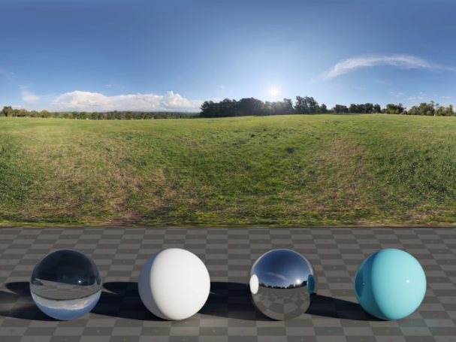

Figure – J&E Gray Park (Zaal, n.d.)

#### Preparing the cliff

Because of the use of a texture, it is best practice to activate the “Import Images as Planes” addon in Blender to make things easier and have the plane in the textures’ ratio. To have the cliff look the closest to the “Foreground Shot – 2D Created Assets – Attempts #2” it was decided to use the ‘Rock 037 – Procedural Texture’ (Figure 37) as it had a similar darker pattern. The 2K quality version was the one used.

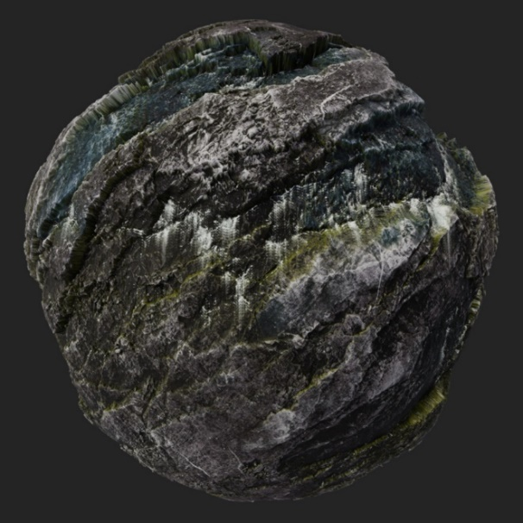

Figure – Rock 037 Procedural Texture (Anon., n.d.)

To import the texture, it was necessary to go “File/Import/Images as Planes” and choosing the “Rock037_2K_Color.jpg”. The first step after importing the plane was to have the bottom of it intersecting the origin point and rotating it to a vertical position. Before continuing, it was important to check if ‘Units’ in the ‘Scene’ settings were in ‘Metric’. Finally, it was time to apply the ‘rotation’ to the object (Figure 38).

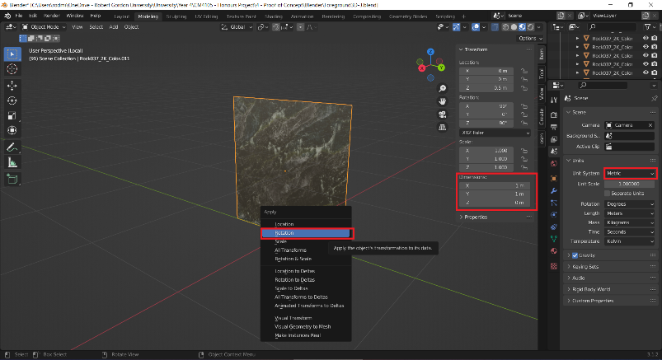

Figure – Setting up the imported plane

Next, a ‘Displacement’ modifier was added, and a new texture applied to it. By going into the ‘Texture’ tab, the default type was changed to ‘Image or Movie’ and the ‘Displacement’ texture that came with the texture downloaded was chosen. Back in the ‘Displacement’ modifier settings, the ‘Texture Coordinates’ were changed from Local to UV, and its strength to 1.1. Afterwards, by going into the ‘Shading’ tab, the default material automatically created when the image was imported, was modified. This was rather an uncomplicated process with the use of Node Wrangler Auto Texturing mode to import the remaining textures to the material. It was now time to add some detail in Sculpting Mode (Figure 39). It was important to add a Multiresolution to add a variance in different resolutions, opening new paths for the sculpting brushes, making the plane present more depth.

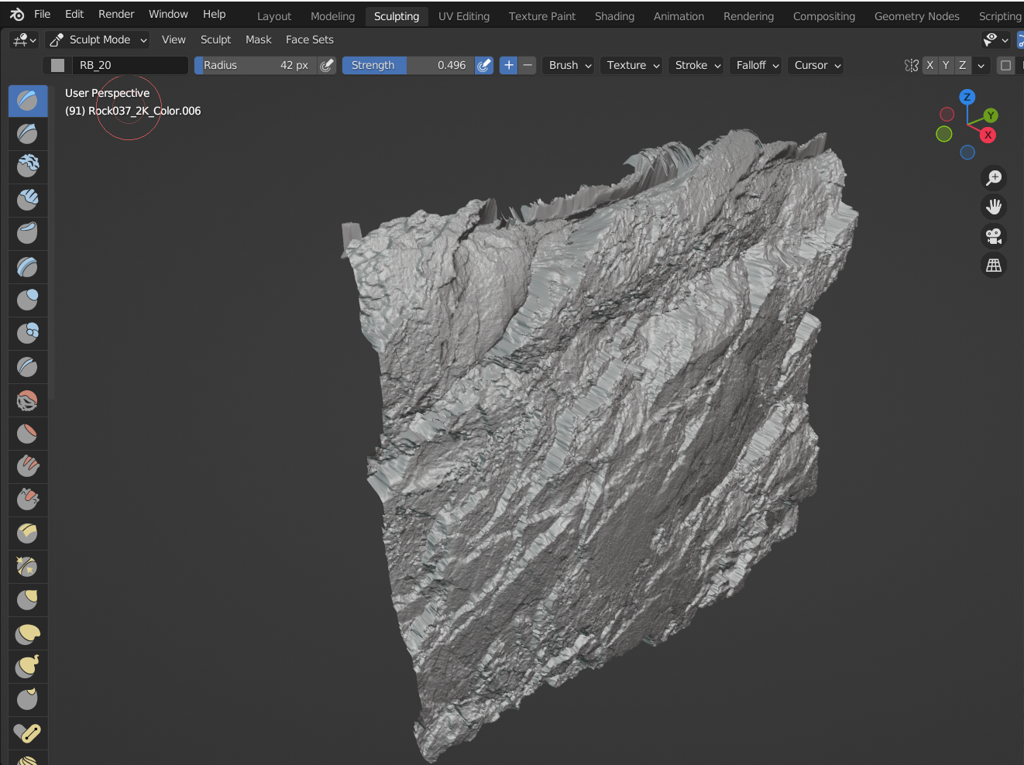

Figure – Sculpted plane

After completing the sculpting, simple grass was the next step to make the cliff more natural. To do this, firstly, it was necessary to go into ‘Edit Mode’ and make the top of the cliff rounder to make the blending easier when in the merging process. To create grass, it was necessary to start by adding a new Particle System to the mesh, setting it up to ‘Hair Type’ and enabling ‘Advanced Mode’. Next, the ‘Emission’ value was set to 200. In the ‘Velocity’ section, the ‘Normal’ value was changed to 0.1 m/s and the ‘Randomness’ to 0.02. On the ‘Physics’ section, the ‘Brownian’ was turned up to 0.010 to add curvature to the grass and, on the ‘Children’ section, ‘Simple’ was selected and the amount of grass particles that would be generated in each turf changed to 30. The ‘Roughness’ uniformity was changed to 0.208 to add more curvature to each plume of grass. Under ‘Endpoint’, its value was changed to 0.162 to make the end of the hair particles slightly more bent, like real grass. Lastly, in the ‘Render’ section of the particles, under ‘Timing’ the value of ‘Random’ was changed to 0.70 to make the grass even more random when rendering (Figure 40).

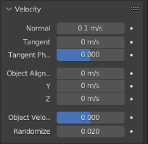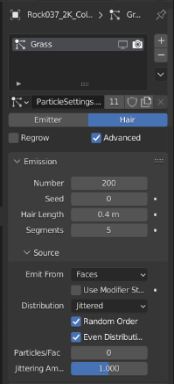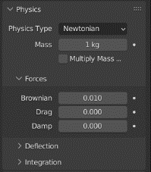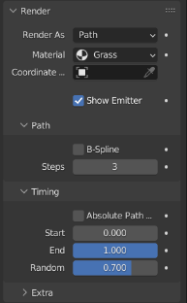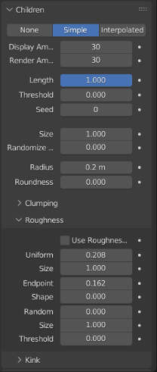

Figure – Particle Effect Settings

Under the ‘Render’ particle settings, a new material was added to the grass, to make it greener, by changing its base colour of the BDSF. Note: Under ‘Render’ it was important to set the material of the particles to match the material created, or it would render as the rock texture!

The last step before Rendering was to weight paint the mesh to clean up grass, growing up in places that should not be growing. By removing the weight in some zones and adding more on others, the cliff become more realistic. After playing around with the brushes, this was the final weight paint (Figure 41), where blue means ‘no grass’ and red ‘grass’, having the in-between colours assume mixing values.

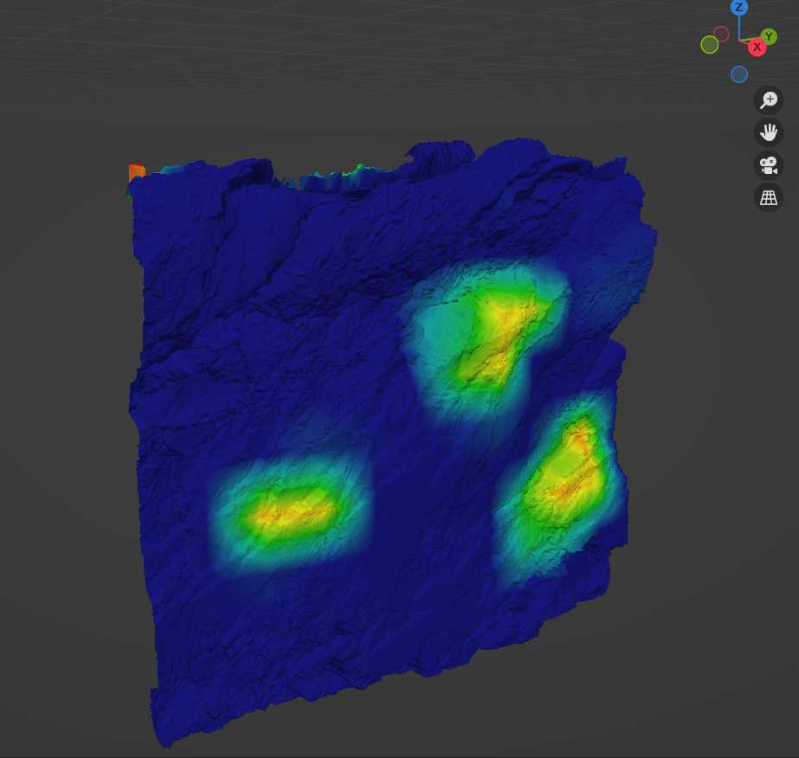

Figure – Weight Paint of the cliff mesh

To finalise, the mesh was copied various times and positioned to fill across the frame of where the camera was looking from. Which, in retrospective, was a bad idea since it left some holes visible in the shadows in the wall. This was fixed by creating a plane and putting it in the back of the whole cliff (Figure 42).

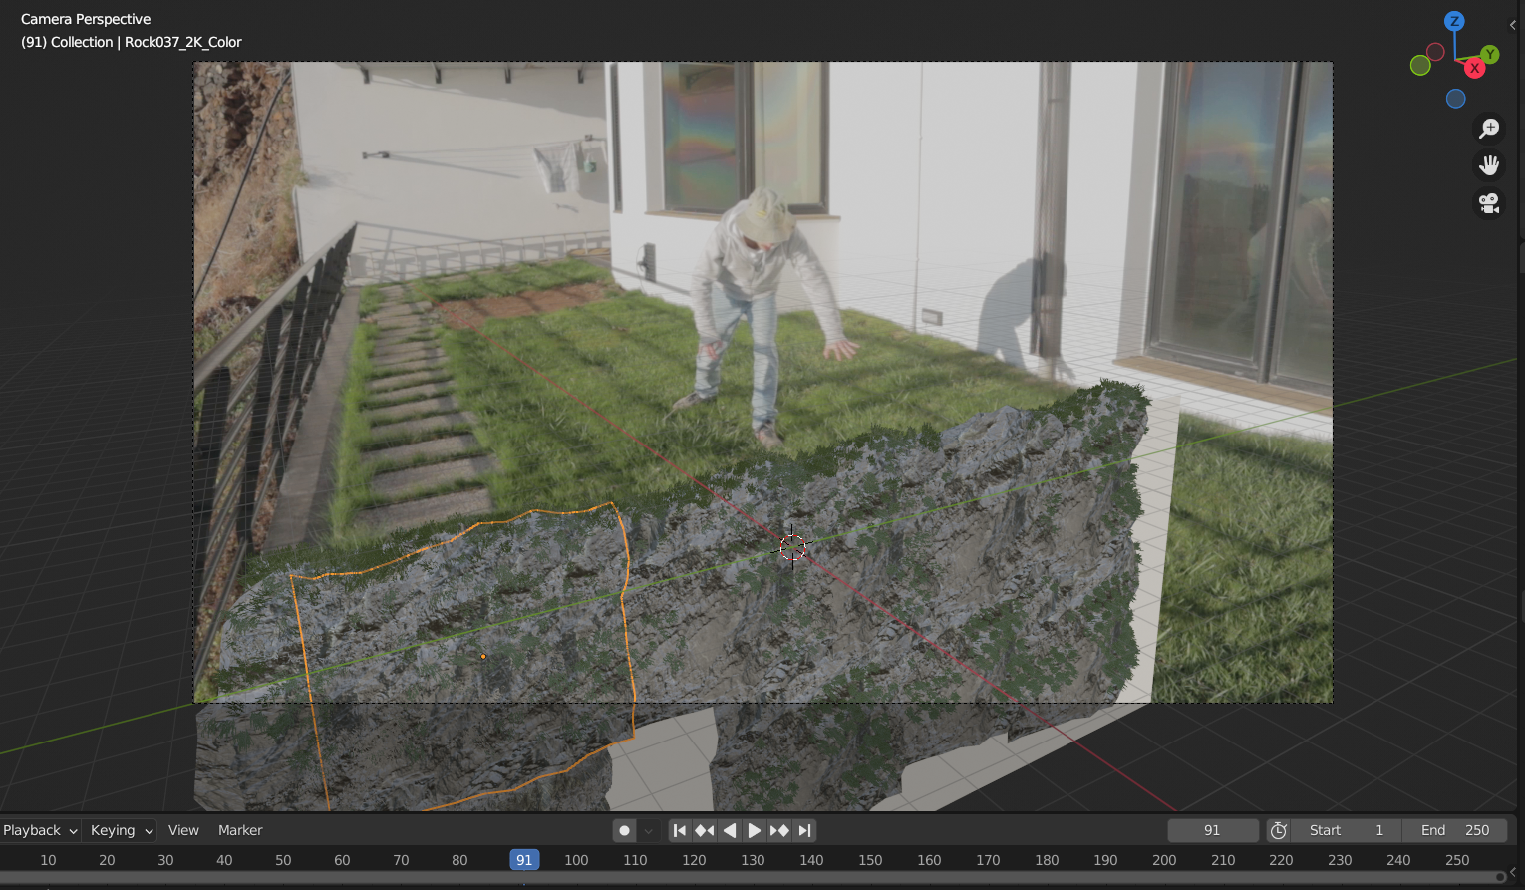

Figure – Viewport Shading of the Cliff

#### Creating the wall

To create the wall, a simple plane was positioned vertically to hide the window from the camera view. Under the ‘Shading’ menu, a new material was applied to the wall and using a procedural generated texture created the cracks on it, which was a very complicated process of connecting nodes (Figure 43). It started off by adding a ‘ColorRamp’ and connecting it to the base colour of the material. Next, a ‘Musgrave’ texture was used and by using the ‘Node Wrangler Auto Setup’ got ‘Texture Coordinate’ and ‘Mapping’ nodes automatically. At this point, it was important to change the ‘Object’ output to the ‘Vector’ input of these and attach the ‘Musgrave’ node to the ‘ColorRamp’. Then, the ‘Dimension’ was taken down to 0 and changed the ‘ColorRamp’ to have a cement like colour material. Next, a ‘Bump’ node was added and connected to the ‘Normal’ input of the material. The output of the ‘Musgrave’ texture was connected to the ‘height’ input of the node and its strength brought down. To add even more detail to the material, a ‘Noise Texture’ node was added, and its factor plugged into the ‘ColorRamp’ factor. Afterwards, its scale was changed to 6 and its detail to 16. A ‘MixRGB’ node was added in to mix the ‘Musgrave’ and ‘Noise Texture’ nodes. It was important to change its type to ‘Difference’ too. In-between the ‘Noise Texture’ and the ‘MixRGB’ another ‘ColorRamp’ node was added to tone the detail down and add dents to the cement. After adjusting its factor, a ‘Voronoi Texture’ node was connected to the new duplicated ‘Bump’ node that was created previously. This allowed the cracks to be created. Using the same command previously used with Node Wrangler, a new ‘Texture Coordinate’ and ‘Mapping’ nodes were added and its output to ‘Object’ changed. In the ‘Voronoi Texture’ the type was also changed to ‘Distance to Edge’ to let the crackle appear. Then, a ‘ColorRamp’ node was added in the output of the ‘Voronoi’ node and the ‘ColorRamp’ values brought to the left. To finish off, a ‘Noise Texture’ node was added to the output of the Object coordinates and the detail dialled in. It its output a ‘MixRGB’ node was dropped and connected its ‘Color 2’ to the object output. When bringing its ‘Factor’ down, the cracks became more visible. It was now time to finalise the Render!

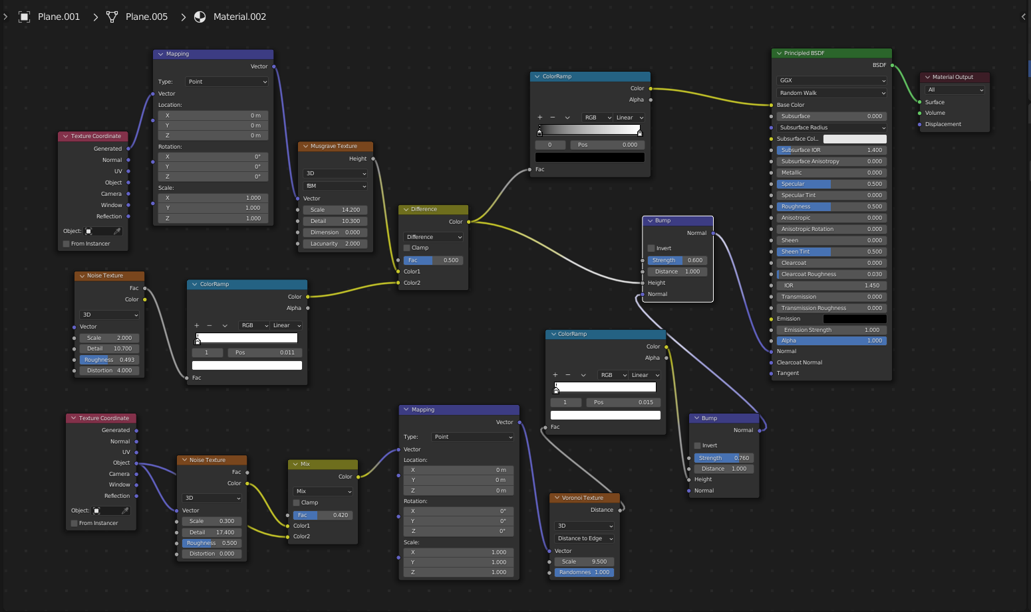

Figure – Surface Cracks – Node Settings

#### Rendering

After fixing up the position of some meshes the scene was ready to be rendered. Leaving the settings on default and after a couple of tries and long rendering hours, the final output (Figure 44) came out as intended.

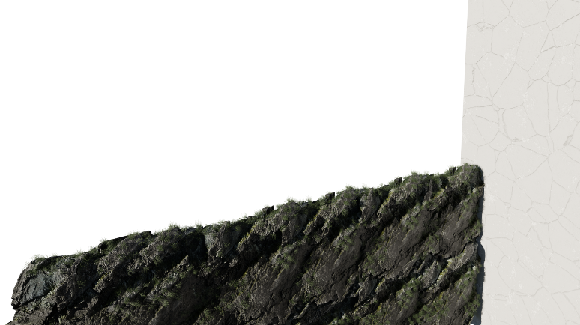

Figure – Final 3D Foreground Attempt #2 – Render

### Background Shot – 2D Created Assets

With the invaluable feedback and experience that was gathered while completing the foreground image assets, the background attempt had every single reason to run better.

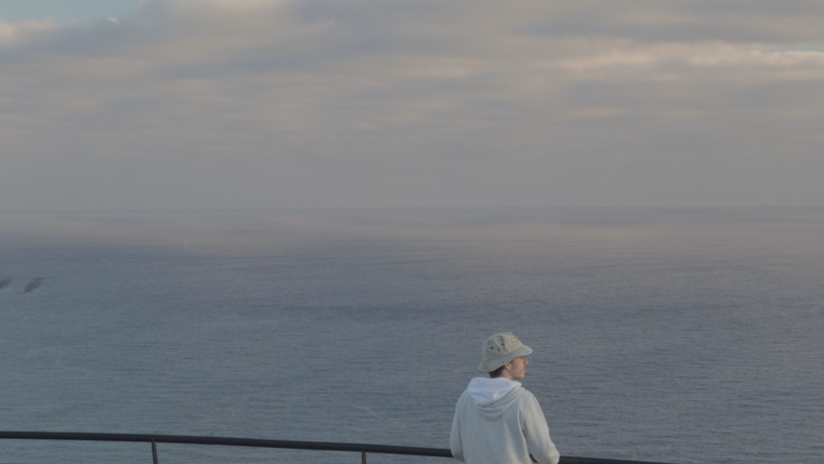

Figure – Clean Foreground Plate

With the clean background plate (Figure 45), the first step was to create a clipping mask on the sky in the background and using the image reference (Figure 48) to see how it would look like.

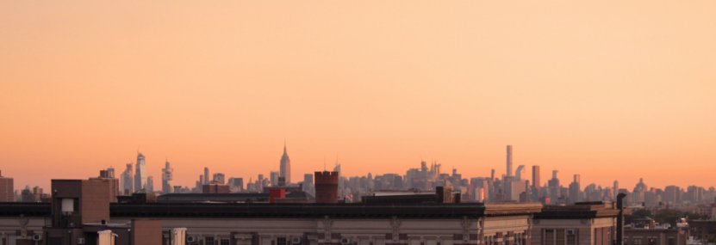

Figure – Sunset in USA city (Anon., n.d.)

Using the sky colour, from the reference, and using the Gradient Tool, a fake sky was created on the background to add a more red/yellow vibe to the composition. By using a layer mask and making the edges of the sea softer the sky was blended in the edit. Next, using a Lower Manhattan panorama viewed from Jersey City (Figure 47), the skyscrapers were masked and brought into the clean plate and positioned to add the city in the background

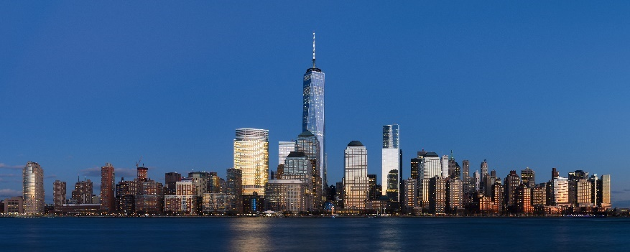

Figure – Lower Manhattan from Jersey City (Anon., n.d.)

Using a vector mask layer and after cleaning the edges to make them blend better with the background, the layer was then duplicated, flipped down, and had its opacity changed to 60%. With the help of a vector mask and some brushes the layer looked more like a shadow. To finalise, some curves, exposure and brightness adjustment layers were added to blend in the blacks better and complete the final version Figure 48.

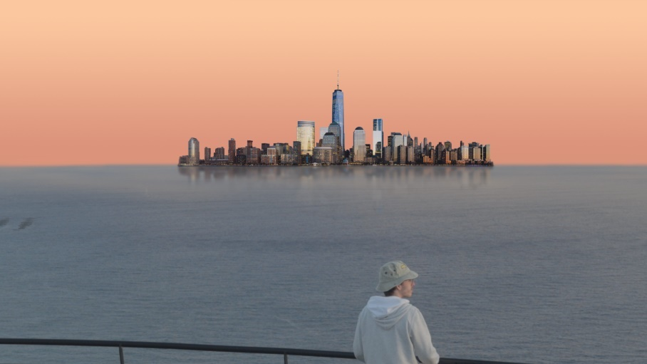

Figure – 2D Background - Final version

### Background Shot – 3D Created Assets

Taking a different approach to building the city in 3D, using Blender opened the door to using a new addon called ‘blender-osm: OpenStreetMap and Terrain for Blender’ (Figure 49) which uses data gathered by other people to reliably build any area of the world without much hassle creating its own mesh in Blender. The addon needs manual installation in Blender, as it comes from an outside source. After it was installed, there was the need to add a folder for it to save the OpenStreetMap data, this could be any folder you would like.

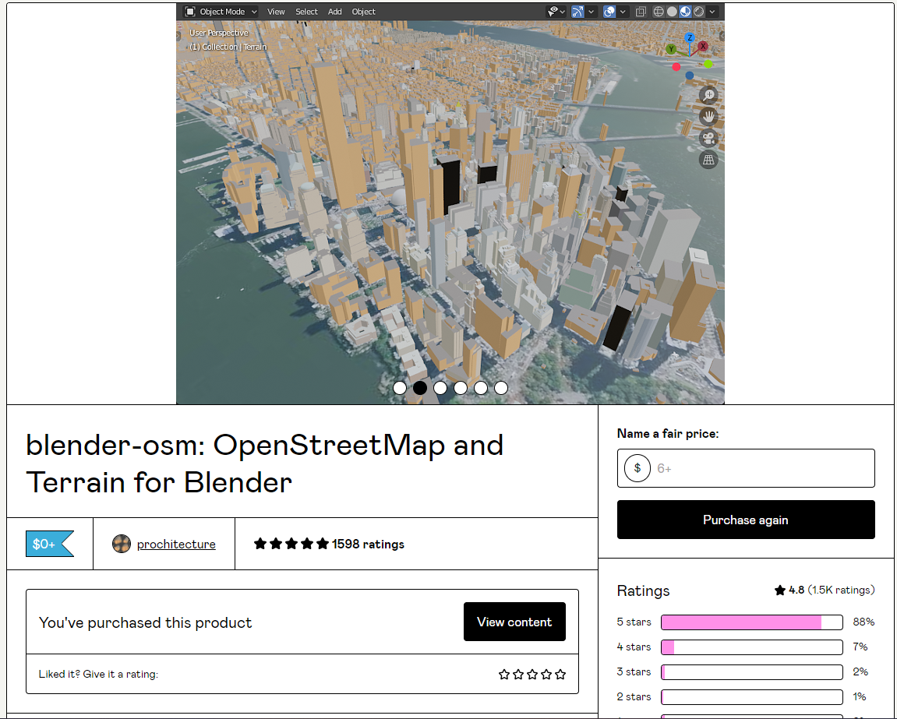

Figure – blender-osm website (Anon., n.d.)

#### Setting up the scene

Starting by importing the “2D Background – Final version” (Figure 48) to the camera, (process previously explained in “Foreground Shot – 3D Created Assets – Attempt #1”) and then adjusting it to match the perspective lines (mostly parallel to the horizon line), the city importation with ‘Blender-osm’ could start.

#### Importing the city with blender-osm

First, there was the need to go to <http://prochitecture.com/> by selecting the ‘Select’ button in the tool options. After finding out where the previous picture, used in the 2D Background, was taken from (Lower Manhattan as seen by Jersey shore side), the area to be imported to Blender was selected and its coordinates copied to be applied in the addon (Figure 50).

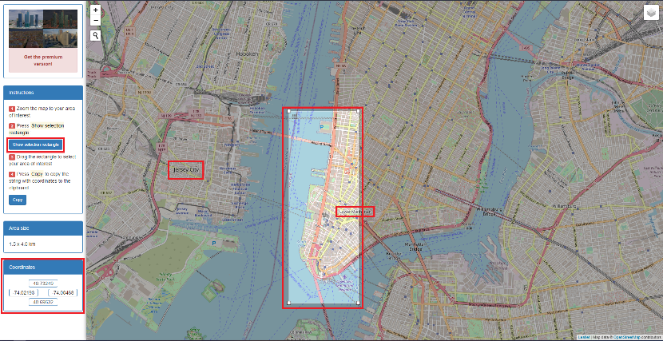

Figure – Website with tool to extract the coordinates of the area to import

Back in Blender, the coordinates were pasted in, and the settings changed from ‘OpenStreetMap’ to ‘terrain’ before hitting ‘Import’. After this was done, because of the size of the city, the Clipping distance had to be changed to 100 000 meters. When the city was imported, the setting was changed to ‘image overlay’ and ‘Import’ was pressed again. After a couple of seconds, the shading was imported. As this texture would be needed later, using the UV Editing tab, the texture was saved in a folder easily accessible later. After changing the settings back to ‘OpenStreetMap’ option, the building meshes were imported and ready to be shaded (Figure 51).

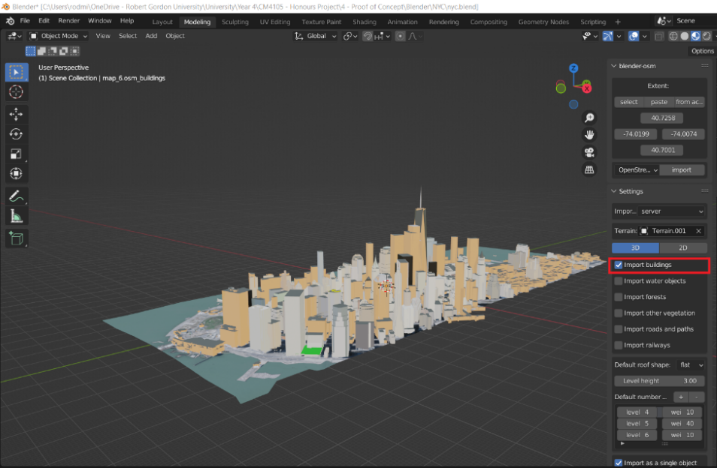

Figure – Imported buildings mesh

#### Shading the City

Before starting the shading process, there was the need to go online and find textures to be used, in a randomly manner, for the buildings. Four different textures (Figure 52) were chosen, “High Rise Residential 103” for the smaller buildings, “High Rise Glass 54” for the tallest office buildings and “Building High Rise 404” for the mid-sized buildings. “High Rise Glass 28” was also chosen to add a bit of sunset colour to the scene into the composition.

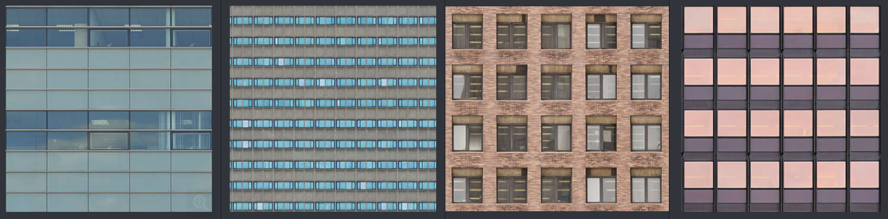

Figure – High Rise Glass 54, Building High Rise 404, High Rise Residential 103 and High Rise Glass 28 respectively

Back to Blender, in Edit Mode, by choosing the ‘roof’ material, which was created automatically by the addon, these were selected and separated from the buildings using ‘Separate Object’. Jumping to the ‘Shader Editor’ and using the ‘Node Wrangler’ addon, a ‘Texture’ node was automatically created. After choosing the image saved earlier with the city satellite view and deleting the UV Maps that were attached to the object, it was now possible to scale down the Texture (Figure 53) and match it with the buildings imported earlier.

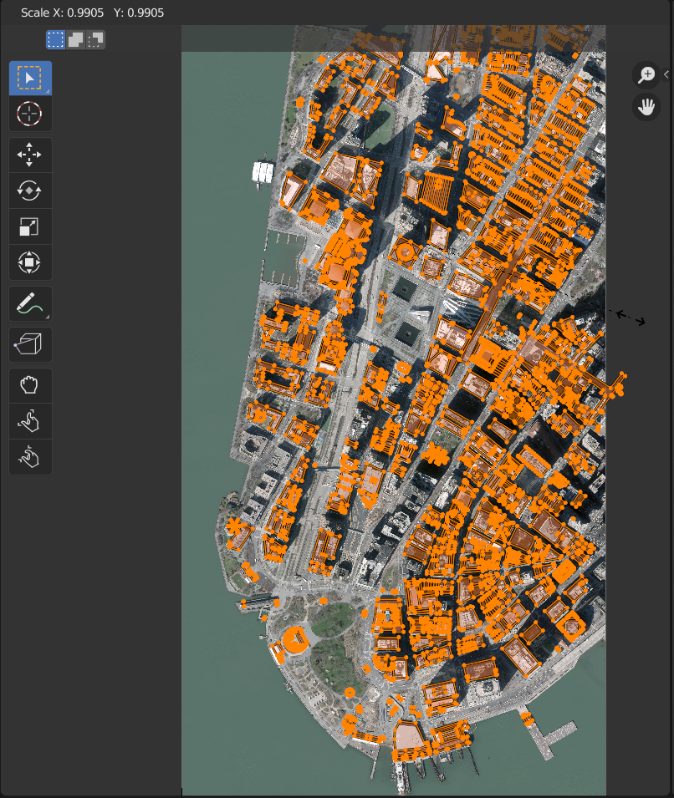

Figure - Matching rooftops with Texture

In Edit mode, all buildings were selected and UV Unwrapped in ‘Cube Projection’ with a Cube size of 0.010. This, along with changing its material settings to ‘Wall’ and then importing the ‘High Rise Residential 103’ texture, gave the buildings the same texture. It was necessary to scale them down to the right size. Next, a ‘ColorRamp’ was needed to isolate the windows and a ‘Bump’ node to add detail into the buildings. Having the process repeated, by duplicating the materials, changing the textures, and assigning them to some buildings, and changing the ‘ColorRamp’ and ‘Bump’ node values (Figure 54), the city was finally ready to render.

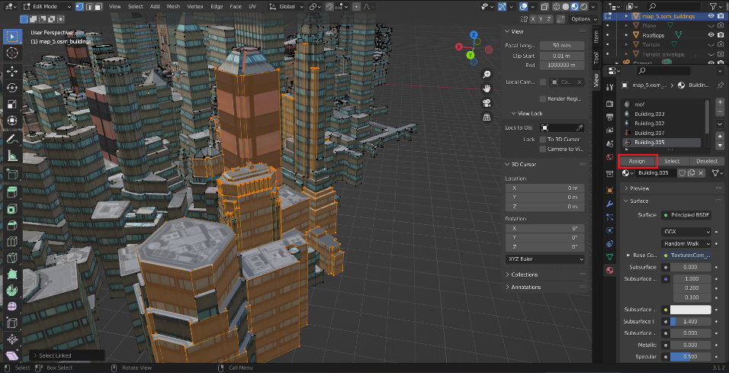

Figure – Assigning the materials to buildings

#### HDRI Setup & Reflection Plane

The HDRI used in this scene was the same as in “Foreground Shot – 3D Created Assets – Attempt #1”, Sunset in the Chalk Quarry (Figure 31), as it had a good light setup which has been discussed earlier. After importing it with the default settings, a plane to work as a mirror on the bottom of the city and get a reflection was also added. It was added with the intention of later being masked and added to the clean plate as the city shadow. To produce the reflections needed, in the ‘Shading’ tab a new simple material was added to the plane, with a ‘Diffuse’ and ‘Glossy’ nodes, alongside a ‘Mix Shader’ creating the reflective surface (Figure 55).

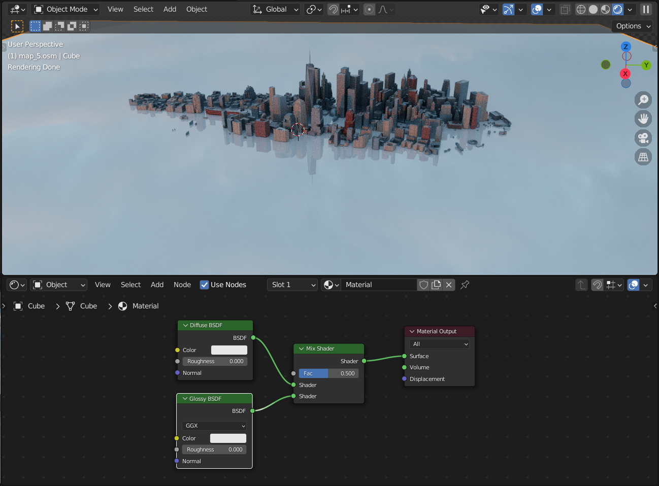

Figure – Use of Plane as reflection surface

#### Render

Matching up the camera of the scene with the “2D Background - Final version” (Figure 48) before rendering was necessary to match up the buildings the best possible, to make the next steps on the pipeline easier when working with Adobe After Effects. After a couple of changes, these were the final Renders. Render 1 (Figure 56), not showing reflection and Render 2 (Figure 57) with the plane showing the reflection of the city on it.

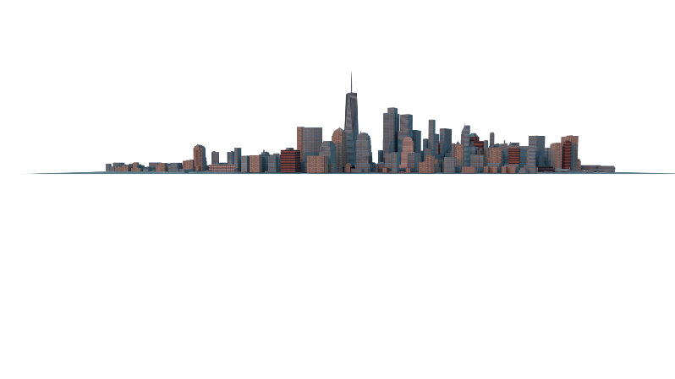

Figure – 3D Foreground – Render 1

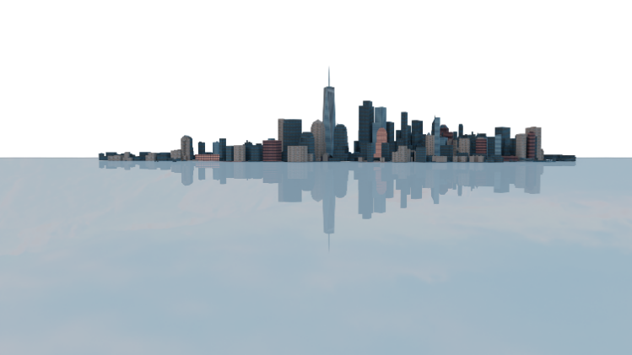

Figure – 3D Foreground – Render 2

### Adobe After Effects

This is where all the previous work comes together, by importing all the assets created and blending them in the clean plates that were recorded previously.

#### Foreground 2D

Starting off by opening a new project in Adobe After Effects, with the default settings but the resolution of 1920x817 to get a cinematic feeling, as known as black bars on top and bottom of the footage, a new composition was created and named “Foreground 2D”. The assets previously created in Photoshop were added until the scene was set up. The ‘wall cracks’ layer had to be duplicated and mirrored to create a fake continuation as it would not be long enough for the camera movement that would be later added. Also, a mask with ‘subtraction’ had to be added to a certain area in the cracks to allow the head of the actor to passthrough without having the cracks appear over it. After that, an adjustment layer was added with a mask on “add” to change the ‘curves’, ‘levels’ and ‘colour’ of the zone where the grass meets the cliff to blend them in better (Figure 58).

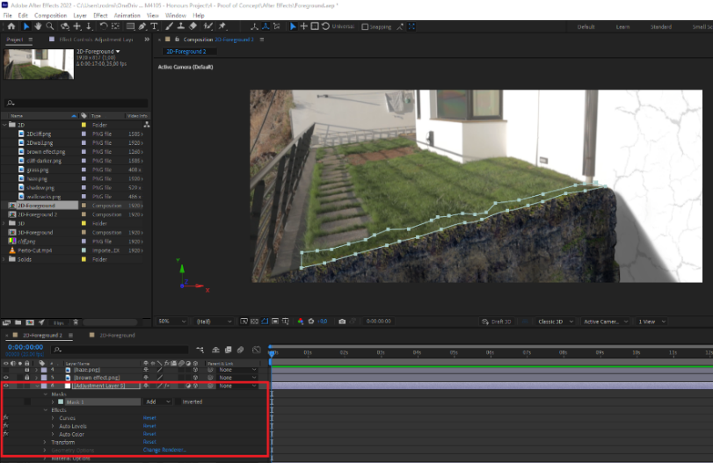

Figure – Adjustment layer – Blending grass and cliff mask

Next, it was time to add the haze (which was used for both 2D & 3D compositions), along with its ‘transform’ keyframes to add fake movement during the shot. Before finishing off, some camera movement was added to fake a handheld shot as in ‘zoom in and out’ of the frame. Under a new Camera layer, a couple of keyframes (Figure 59) were added in areas that made more sense, following the body of the actor and where his head was looking at. When completed, this gave a more dramatic feel to the shot. Next, an adjustment layer was created to colour correct the footage to a certain degree of quality.

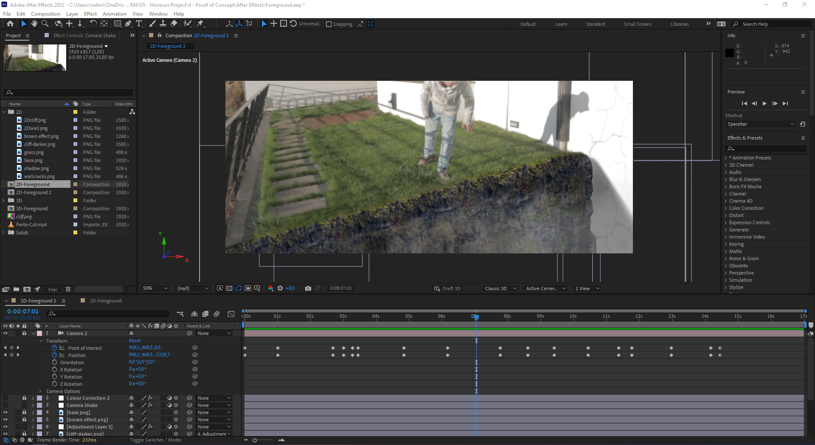

Figure – Keyframes of the camera movement

#### Foreground 3D

For the 3D assets, a duplicate of the 2D composition was done to preserve the camera movements and haze. Everything else was deleted. After placing the render, previously done in Blender, a couple of masks with subtractions had to be added to the cliff and the wall (Figure 60), as a way of blending them in the video better. An adjustment layer to bump the cliff exposure was also added as it looked very dark on video. Another adjustment layer to add blurriness to the top of the cliff was used, and three adjustment layers were used to fix the colour of the wall and blend its colour to the clean plate while still showing the cracks. Lastly, an adjustment layer with colour correcting effects was added to make the footage more uniform. And it was ready to be exported.

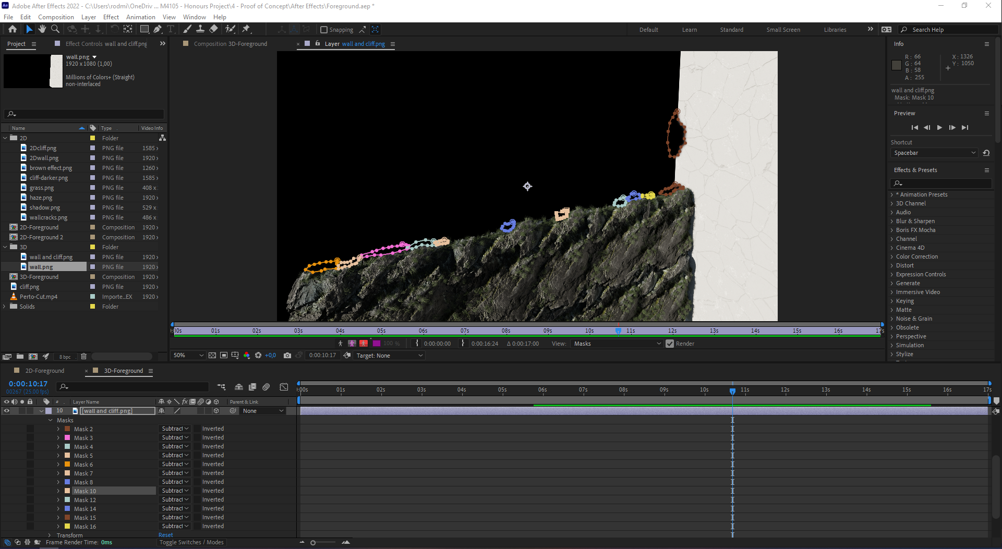

Figure – Masks on the wall and top of the cliff

#### Background 2D

For the 2D background shot, a new file was created with the same resolution settings as the previous ones. By importing the clean plate of footage and masking the sky to add the gradient layer previously created the footage started to have a warmer dusk feel. Then, the city layer previously curated in Photoshop was added, alongside an adjustment layer to add wiggle to the camera view. Using the wiggle function and slider control effect (Figure 61) the camera got a handheld camera shake added to it, which was controlled by the slider control and it’s different keyframes left during all the duration of the shot.

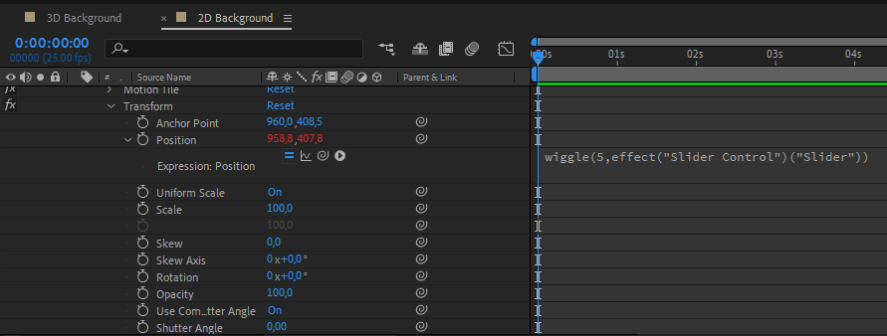

Figure – Wiggle effect with slider control variable

To finish off, a fake mask with two circles was created to make a fake a binocular’s view (Figure 62) to allow the positioning of the camera exactly where needed, and later add the real one in Premiere Pro. A camera movement and zoom layer were added to the shot alongside an adjustment layer with fake focus blur on the binoculars when changing distance of focus. This was achieved with the help of keyframes throughout the duration of the clip, leaving it ready to be rendered (without the binoculars mask).

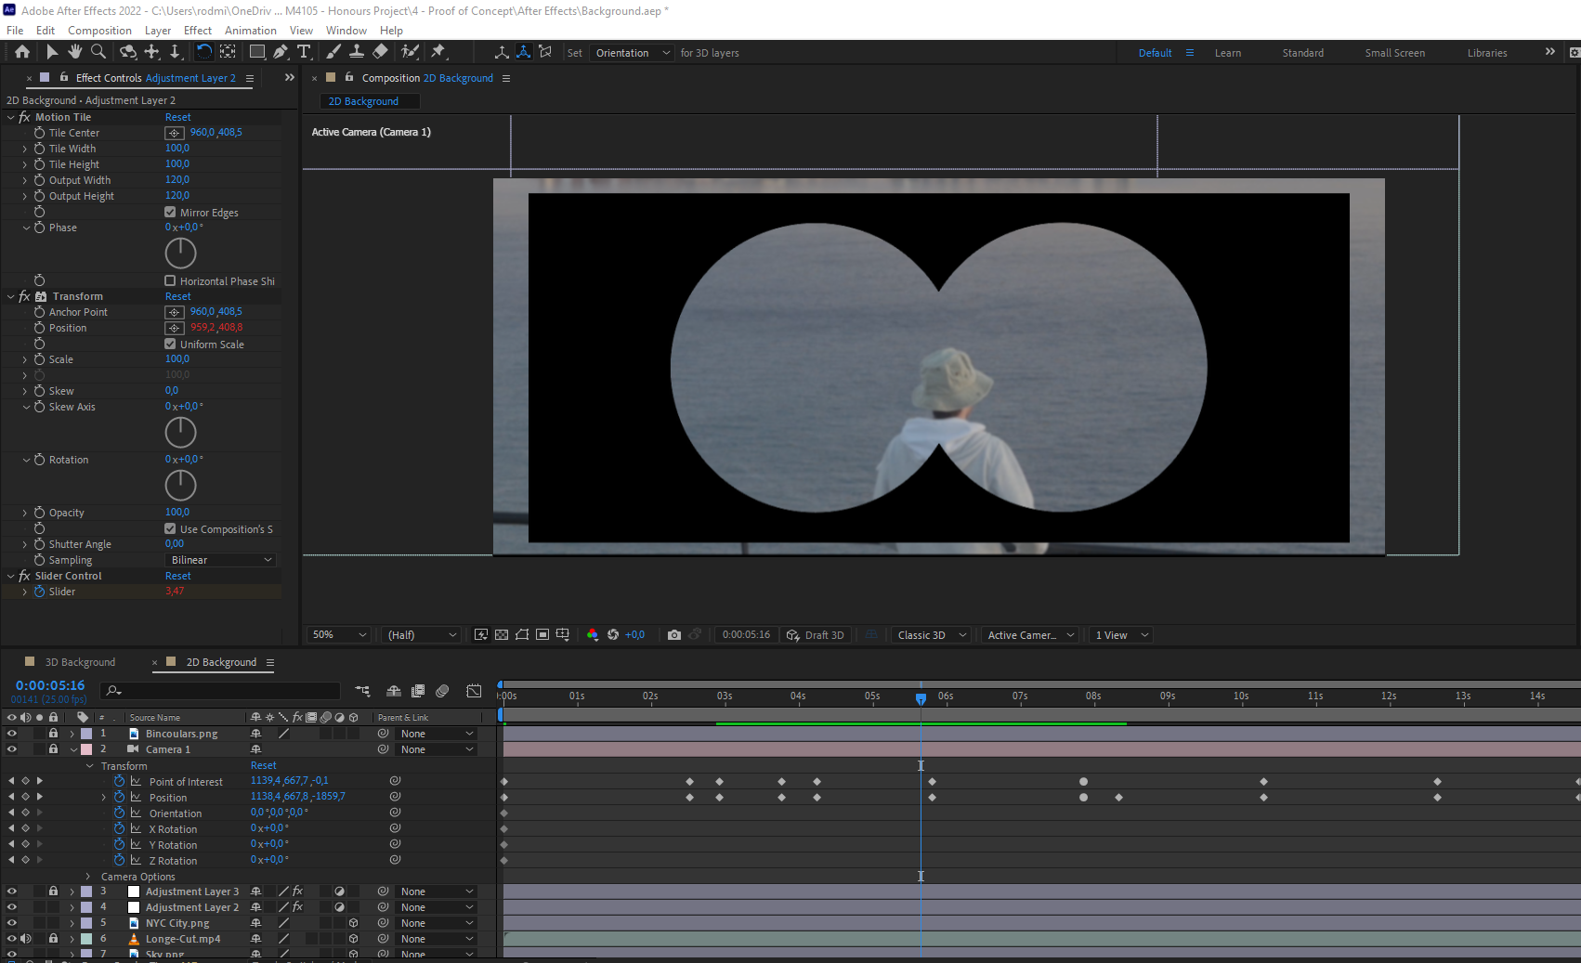

Figure – Camera movement and placeholder binoculars mask

#### Background 3D

For the 3D assets, a copy of the 2D composition was used to preserve the camera work done previously and maintain uniformity between clips. The sky gradient was also kept. Then the city render (without the reflection) was added, and its edges masked to hide the remaining’s of the terrain. Consequently, the render with the reflection was added and everything else masked off (Figure 63) only leaving the reflection to be used, with its opacity changed to 25% it was now ready to be exported.

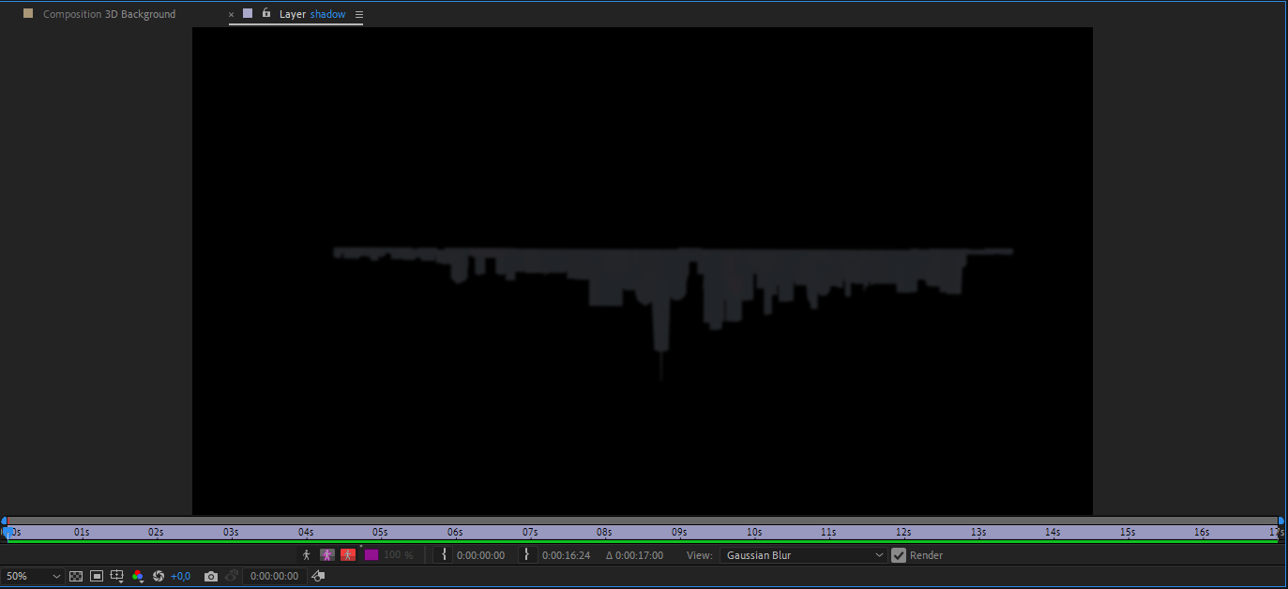

Figure – Shadow mask

#### Rendering & Exporting

All the above compositions were exported in H.264 codec with the 1920x817 resolution and later imported into Adobe Premiere.

### Adobe Premiere Pro

#### Binocular’s layer

After adding both 2D and 3D background exports to Premiere Pro. A solid black layer was created, and two circles added to be used as masks. By subtracting the difference between the layers, a view that looked like binoculars (Figure 64) was created. Both videos were then exported to be later used in the survey and presentation.

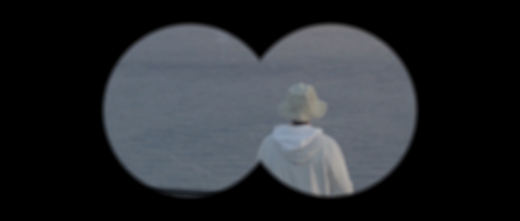

Figure – Final Binoculars Mask

#### Preparing the Final Presentation

To show what was achieved during the duration of this project, a small video was edited with all the exports (Figure 65) and all were assembled as a running video presentation to show people and supervisor alike, in the Poster Demo and as a final deliverable.

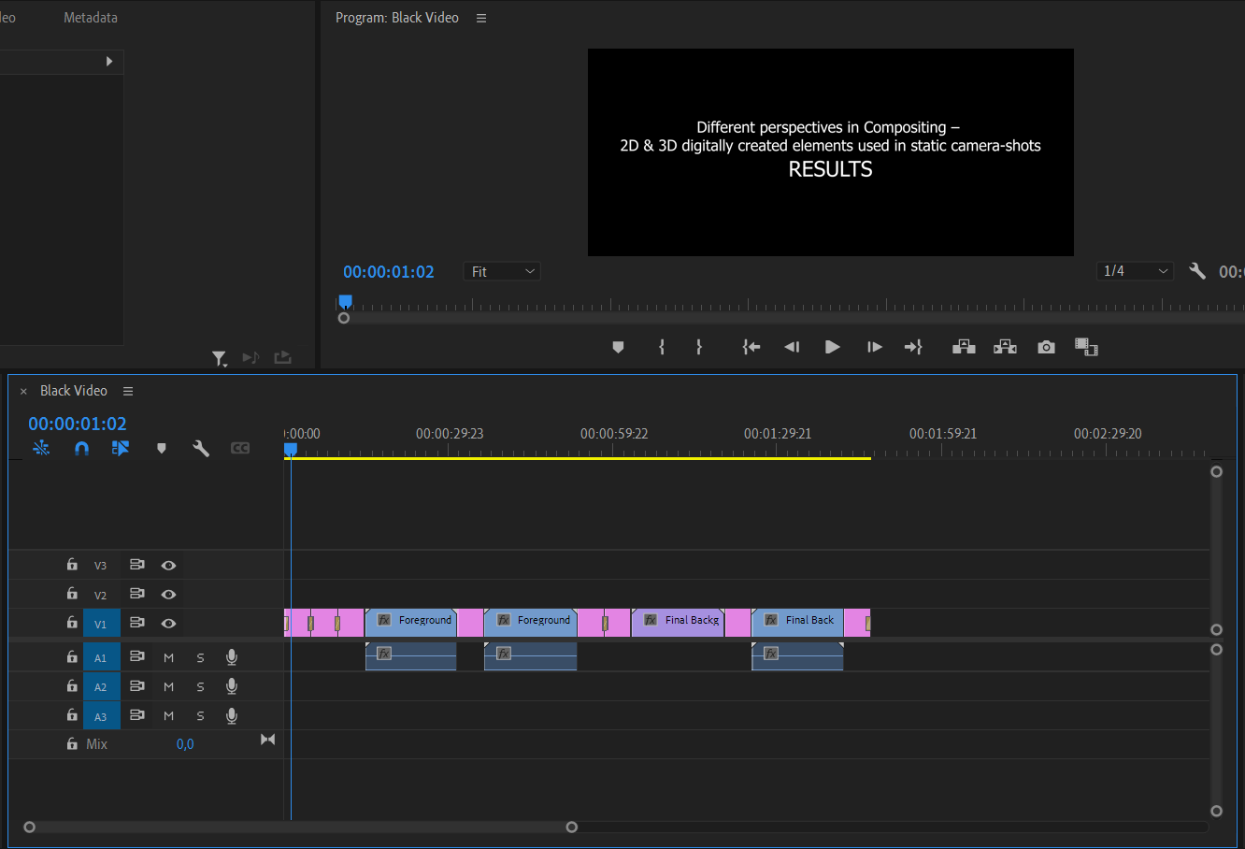

Figure – Premiere Pro – Presentation Workspace

# Testing

## Introduction

To understand better how different digitally created assets are perceived by ordinary people, I built a survey with questions that would try to gather information on various subjects. A survey was the most reliable and consistent way of getting to a ‘wide’ audience without much effort or time spent. With the information gathered, it was time to analyse it and come up to some conclusions. The survey was anonymous which helped with the honest answers and consequently, there was no need to consider any GDPR issues that might have aroused later.

## Methodology

The survey consisted of four different sections, each with a different objective in what kind of information to get from the participants. The first section was used to separate people that have no knowledge in Visual Effects and people that do, while also gathering information on which techniques are more known between them. The second section tells the participants to watch both Foreground videos (2D & 3D) and questions them on which they think looks better, how/if they spotted any differences, what they would have done differently and which one they think was done with 3D software. The third section follows the same path as the second one focusing on the Background shots. The fourth and last section asks the participants about how long they think these shots took to make and the number of programs used in the pipeline to get to the final product.

## Results & Analysis

With a participant’s number of 16, the results showed that while 81.3% of them knew what Visual Effects were, only 25% have had any experience on doing them (Figure 66). It also showed that Computer-Generated Imagery is by far the most known VFX technique.

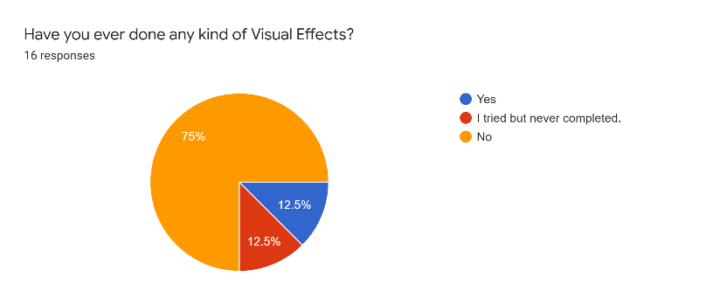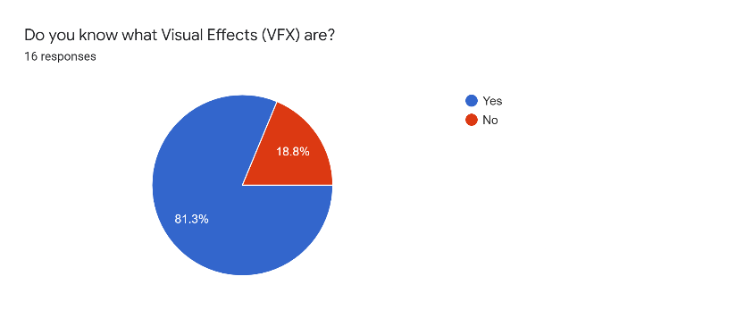

Figure – Survey Results – VFX related questions

Regarding the ‘Foreground’ clips with the different digitally created assets, 75% of the participants said that the 2D version looked better than the 3D. The main reason for this happening is the lack of shadow (or incorrect use) in the 3D assets clip, the repeating pattern that was spottable by some users and the lack of visible wall cracks. When asked about which one had the 3D created assets there was no consensus and the answers were 50/50.

Over in the ‘Background’ section, both 2D and 3D assets were eye-candy as the users said not one or the other looked better and could not state any big differences that made them stand out even though they were achieved with different techniques. Some participants also mentioned that lack of land mass threw them off, while the city was too sharp in the 2D assets. The question regarding which one was made using 3D software had an 87.5% of wrong answers which leaves the question “Does 2D achieve 3D looking results without the amount of work and skill?”

To finish off, the answers regarding the times that the shots took to make had responses in all the options with the most answered one being “2-5 hours”. However, when filtering only the answers of people that have had any interaction with Visual Effects there is more awareness on how long these effects take to make. While the sample of participants in this case was small (four), out of these, two, chose the “30+ hours” option. In retrospective, this question, was badly done and should have asked on average what time would take to make each of post-production changes to the shots. Lastly, to know if the participants had any idea on how many programs the pipeline of a VFX work takes, the question was answered with answers from 1 to 4 with over 56% of the people choosing 3 programs were on average used (Figure 67).

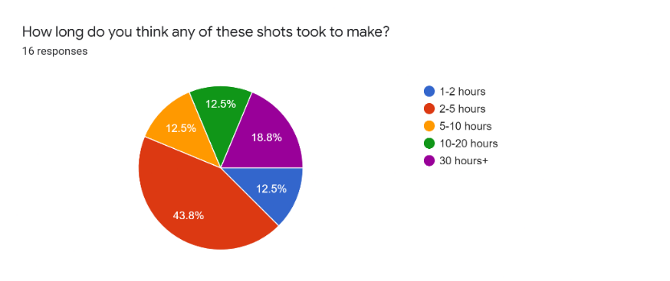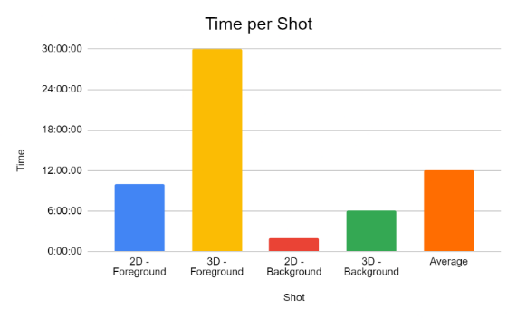

Figure – Results on time taken to complete the shots vs. real time

## Conclusion

After gathering and taking time to analyse the various quantitative and qualitative types of answers of the survey, it is safe to assume that there is still a lot of disinformation regarding the VFX sector to most people. When questioned about how long or how many programs are necessary to achieve a digitally modified shot, there is no “predefined” answer and people do not seem to be able to spot the difference between differently created assets. It is not as easy to identify differences in a background plane while in foreground types of shots its very much up to the quality of the creator. While some mistakes were present in the survey, it was enough to conclude that sometimes 3D is not always better/more realistic and the time difference and amount of work necessary to have an accomplished product that this brings can be better used in other types of shots or situations if the team is small and has less monetary opportunities.

# Evaluation

## Reflection

As a reflection, this project did not go as planned from the very beginning. VFX is a very intricate and interesting area but the lack of knowledge from me and lack of information available in scientific papers put it in a precarious position as I was not sure what to work on during the beginning stages of it. It eventually came back to its feet but if I were to start over, I would have tried to nail down the subject earlier than I was able to. This created a couple of issues when writing the Literature Review which then was not self-explanatory of what exactly I was working on, thus creating something I was not sure that would have gone in the right direction.

There were a couple of things that I was not expecting the project to take as much as it did, in fact, the planning was more needed than what I initially envisioned, and I still did not make as much as I should have and that can be seen during this thesis and in the final product. The hardware used was enough for my needs, however, my own mistake, by not researching more on how to create HDRIs, might have hindered my own chances of creating something more realistic when building the 3D models later. During production, the scenery used was not the best causing problems that were only found out later, mainly for my lack of experience in these types of productions. If I were to do it over, for the foreground shot I would have gone to a wider place, where grass was the only thing that could be scene from one side to the other of the frame and would have put the camera slightly lower and with less of an angle. Also, the actor would have had to fake their fall a couple of meters behind to build more of the cliff and having more of it showing. I should have listened to my supervisor and searched for more reference shots that would have helped immensely here and I wish I would have had more time to watch more movies that are VFX milestones to understand them better. Also, I would have enjoyed having done the midground shots as mentioned in the requirements, thing that did not happen, but I do not think that with the time constraints would have been possible anyway. Another thing that was missing, was the lack of documentation of the production phase, where a couple of photos would have been nice to complement more “Production” text, which would have needed to touch on more cinematography subjects, including shots, lighting, and a deeper consideration on the VFX that was on my mind when recording these. This did not happen due to my stubbornness and is, unfortunately, a missing addition that would have taken the project to another level of comprehension. Also, the lack of note taking regarding the lens and camera settings hurt the quality of the work as these were necessary to have a more realistic 3D environment. Mentioning the camera, the use of a flat colour profile did not help when colour correcting due to the ‘curves’ settings that these kinds of profiles have. For a beginner, these kinds of mistakes start to add up and become a snowball that is hard to stop, or fix, later in the pipeline. Also, trying to colour-correct the footage after importing it to Premiere Pro was not one of my most smart ideas and made the blending process a mess later, having me starting it over again, because the digitally created assets were not matching the edited footage and arouse other problems when working with the 3D assets. Unfortunately, the lack of skill when building 3D environments, and my weakness, shading, can be seen throughout the project. I tried my best to match both image assets the best I could, but 3D demands so much more knowledge, trial, and error that it is very difficult to get right. This had influence in some of the results of the testing phase and if, to be done again, would need to improve on this front.

Lastly, the loss of the image references used in the Photoshop process is something that hinders the scientific credibility of this paper and should have been taken with more professionalism.

## Project Conclusion

The project can take some conclusions with the information gathered during the testing phase and during the documentation phase. Creating VFX is not as easy as it may seem, and endless undocumented hours happen more than you would think. Also, before doing any kind of VFX work it is necessary to go on the lookout for ideas, references, and study them properly to take your work to the next level. It is not an easy task, nor will it ever be. It is easier with the software that is available today if compared to fifty or a hundred years ago, however it will always be a very artistic type of work with attention to detail and many hours lost trying to perfect every frame. Compositing is the combination of all other, important, VFX techniques and without them it would never exist. Albeit being unknown to many people, those who like it will persist and consistently improve their technique even if it takes years to become respectable at their job and a better documented science/art. In relation to creating assets, the thesis proved that when working with fixed camera shots it is easier and less time consuming to work with 2D and leave the 3D assets only for moving camera shots. As these take much longer to produce and much more knowledge to be at a realistic level. For smaller productions and money deprived environments, the building of 2D assets to be assembled in video are a great cost-benefit way of building creative and realistic stuff that can trick the eye of the unaware viewer and find their way to the cinema screen.

## Future Work

While a good chunk of work was done to try and understand how the creation of digital 2D and 3D assets is made and used in fixed camera shots, the VFX scene is very broad and still lacks scientific work that could help understand more the process without having to getting into the full pipeline of the work. More documentation is a viable option to bring more awareness on how this ‘art’ works and how it can be more efficient in all stages of creation. I would encourage work to be continued in the midground plane and studied all of these using moving shots, which should add a new dimension to the area of study.

# References

Anon., n.d. *Amazon.co.uk.* [Online]   
Available at: https://www.amazon.co.uk/AmazonBasics-60-Inch-Lightweight-Tripod-Bag/dp/B005KP473Q  
[Accessed 20 04 2022].

Anon., n.d. *Amazon.co.uk.* [Online]   
Available at: https://www.amazon.co.uk/Concept-Polarising-Filter-Circular-Polarizing/dp/B07ZVGQH6P  
[Accessed 20 04 2022].

Anon., n.d. *Beautiful Free Images & Pictures | Unsplash.* [Online]   
Available at: https://unsplash.com/  
[Accessed 23 04 2022].

Anon., n.d. *blender-osm: OpenStreetMap and Terrain for Blender.* [Online]   
Available at: https://prochitecture.gumroad.com/l/blender-osm  
[Accessed 23 04 2022].

Anon., n.d. *Canon M50 Review: Canon releases their first 4K mirrorless.* [Online]   
Available at: https://www.imaging-resource.com/PRODS/canon-eos-m50/canon-eos-m50A.HTM  
[Accessed 20 04 2022].

Anon., n.d. *Canon M50 Review: Canon releases their first 4K mirrorless.* [Online]   
Available at: https://www.imaging-resource.com/PRODS/canon-eos-m50/canon-eos-m50A.HTM  
[Accessed 20 04 2022].

Anon., n.d. *Lower Manhattan from Jersey City November 2014 panorama 3.jpg - Wikipedia.* [Online]   
Available at: https://en.wikipedia.org/wiki/File:Lower_Manhattan_from_Jersey_City_November_2014_panorama_3.jpg  
[Accessed 23 04 2022].

Anon., n.d. *Nikon D3300 Review.* [Online]   
Available at: https://www.imaging-resource.com/PRODS/nikon-d3300/nikon-d3300A.HTM  
[Accessed 26 04 2022].

Anon., n.d. *Rock 037 on ambientCG.* [Online]   
Available at: https://ambientcg.com/view?id=Rock037  
[Accessed 22 04 2022].

Anon., n.d. *Rock 038.* [Online]   
Available at: https://3dtextures.me/2020/01/14/rock-038/  
[Accessed 21 04 2022].

Anon., n.d. *The Legal Side of Filmmaking and Video Production • Filmmaking Lifestyle.* [Online]   
Available at: https://filmlifestyle.com/legal-side-of-filmmaking/  
[Accessed 27 04 2022].

Eldin, N. M. S., 2012. Visual Effects Cinematography - The Cinematographer's Filmic Technique from Traditional to Digital Era. *The Turkish Online Journal of Design, Art and Communication,* 2(2), pp. 115-122.

Lamm, C., 2018. *The Importance of Visual Effects in Film Narrative and Film Theory,* s.l.: TigerPrints.

Maio, A., 2021. *What is VFX? Defining the Term and Creating Impossible Worlds.* [Online]   
Available at: https://www.studiobinder.com/blog/what-is-vfx/  
[Accessed 16 11 2021].

Majboroda, S., n.d. *Sunset in the Chalk Quarry HDRI • Poly Haven.* [Online]   
Available at: https://polyhaven.com/a/sunset_in_the_chalk_quarry  
[Accessed 21 04 2022].

Okun, J. A. & Zwerman, S., 2020. Performance and Motion Capture. In: *The VES Handbook of Visual Effects: Industry Standard VFX Practices and Procedures.* s.l.:Focal Press, pp. 481-497.

Ostasheva, A., 2015. *Digital Compositing in the VFX Pipeline,* s.l.: s.n.

Phoka, T., Jariyawattanarat, W. & Sudsang, A., n.d. *Fine Tuning for Green Screen Matting,* s.l.: s.n.

Raditya, C., Rizky, M., Mayranio, S. & Soewito, B., 2021. The Effectivity of Color For Chroma-Key Techniques. *Procedia Computer Science,* Volume 179, pp. 281-288.

Stout, A., 2013. *The History of VFX Part Two: The Model Men.* [Online]   
Available at: https://www.redsharknews.com/technology-computing/item/555-the-history-of-vfx-part-two-the-model-men  
[Accessed 16 11 2021].

Stout, A., 2019. *The History of VFX - Part One: From Mary Queen of Scots to Citizen Kane.* [Online]   
Available at: https://www.redsharknews.com/production/item/530-the-history-of-vfx-part-one-from-mary-queen-of-scots-to-citizen-kane  
[Accessed 16 11 2021].

Venkatasawmy, R., 2012. VFX - Intensive Filmmaking: An Historical Overview. *TMC Academic Journal,* pp. 17-31.

Yin, L., 2014. *Automatic Stereoscopic 3D Chroma-Key Matting Using Perceptual Analysis and Prediction,* Ottawa: s.n.

Zaal, G., n.d. *J&E Gray Park HDRI • Poly Haven.* [Online]   
Available at: https://polyhaven.com/a/je_gray_park  
[Accessed 21 04 2022].

# Appendices

## Project Proposal

## Ethics Form

## Film Call Sheet

## Risk Assessment

## Shooting Schedule

## Storyboards

## Project Poster

## Project Log

Week 1

24/09/2021

Meet & Greet w/ Supervisor

Questions regarding the module and discussion of project ideas.

First class

Week 2

1/10/2021

Questions about the first submission.

Proposal & Ethics started.

Week 3

8/10/2021

Proposal & Ethics Submission.

Week 4

15/10/2021

Research about topics of interest.

Week 5

22/10/2021

Continued research about topics of interest.

Week 6

29/10/2021

Started Literature Review.

Week 7

5/11/2021

Continued Literature Review creation.

Week 8

12/11/2021

Meeting about Literature Review.

Nail down some project ideas.

Week 9

19/11/2021

Literature Review submission.

Week 10

26/11/2021

Researched application and methods to apply for Proof of Concept and set Requirements.

Week 11

3/12/2021

Continuation of search for application and methods to apply for Proof of Concept and set Requirements.

Week 12

10/12/2021

Meeting to talk about next submission.

Questions regarding the requirements.

Week 13

17/12/2021

Start of Requirements document.

Week 14

24/12/2021

Requirements Submission hand in.

Christmas week.

Week 15

31/12/2021

First planning.

Recording takes place.

Week 16

7/01/2022

First Proof of concept ideas.

Started 2D & 3D Foreground.

Week 17

14/01/2022

Continuation of 2D & 3D Foreground concepts.

Week 18

21/01/2022

Started 2D & 3D Background concepts.

Week 19

28/01/2022

Finished 2D & 3D Foreground concept.

Week 20

04/02/2022

Finished 2D & 3D Background concept.

Week 21

11/02/2022

Meeting of Proof of Concept.

Data and opinions gathered, to improve final project.

Week 22

18/02/2022

More research on references to improve final project.

Week 23

25/02/2022

More research on references to improve final project.

Week 24

04/03/2022

Class about Last submissions.

Week 25

11/03/2022

Restarted 2D & 3D Foreground assets.

Week 26

18/03/2022

Casual meeting to talk about what the situation of the project was.

Week 27

25/03/2022

Finished 2D & 3D Foreground assets.

Week 28

1/04/2022

Restart 2D & 3D Background assets.

Final meeting before Spring Break.

Week 29

08/04/2022

Finished 2D & 3D Background assets.

Week 30

15/04/2022

Prepare project to be presented.

Final plates exported to be blended in After Effects.

After Effects & Premiere Pro exports done.

Week 31

22/04/2022

Finished Poster.

Start of the Report.

Week 32

29/04/2022

Poster Presentation.

Finalised the report. Hand in all necessary files.

## Survey

